Name:
ID:
[ 1 – 3 points] If the acceleration, a, of a particle moving with uniform speed, v, in a circle of radius, r, is proportional to some power of r, say r^{m}, and some power of v, say v^{n}. What are the correct values of m and n? Assume that a=k r^{m} v^{n}, where k is a dimensionless constant. Use dimensional analysis to find the answer.
Solution: The dimension of acceleration is [L][T⁻²]. The dimension of r is [L], and that of v is [L][T⁻¹]. Therefore one can setup equations as follows:$\left[{\text{LT}}^{−2}\right]={\left[L\right]}^{m}{\left[{\text{LT}}^{−1}\right]}^{n}=\left[L^{m−n}T^{−n}\right]$. Therefore, n=2 and m=-1. The answer to this question is 3.
- n=2, m=3 2. n=-1, m=2
3. n=2, m=-1 4. None of the above

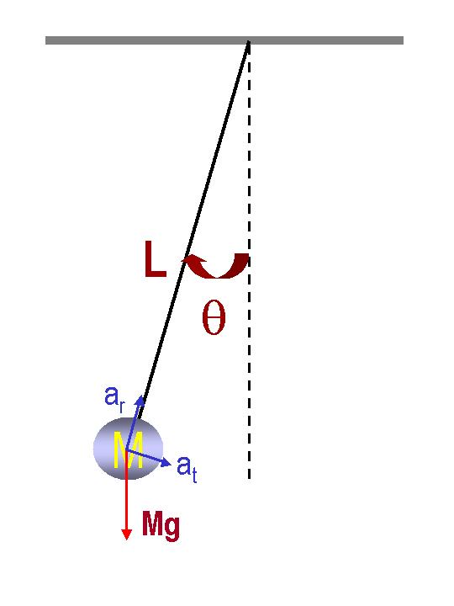
[ 2 – 15 points] A ball of mass M is tied to a massless string of length L and is swinging under the influence of Earth’s gravitational field, as shown in the figure. Answer the following series of questions.
- What is the radial acceleration at the time when the ball’s speed is v and the angle
is θ as shown in the figure above (3 points)?
Solution: Since radial acceleration depends on the speed and the radius of a circular motion, the answer is given at number 3. Also shown in the above problem #1.
1. $a_{r}=g\text{sin}θ$ 2. $a_{r}=g\text{cos}θ$
3. $a_{r}=\frac{v^{2}}{r}$ 4. None of the above
- What is the tangential acceleration at the time when the ball’s speed is v and the angle is θ (3 points)?
Solution: Since the tangential component of the force from the net force equation is${\text{Ma}}_{t}=\text{Mg}\text{sin}θ$, therefore the tangential component of the acceleration is $a_{t}=g\text{sin}θ$.
1. $a_{t}=g\text{sin}θ$ 2. $a_{t}=g\text{cos}θ$
3. $a_{t}=\frac{v^{2}}{r}$ 4. None of the above
- How does the speed of the ball depend on mass (3 points)?
Solution: As shown in the above two problems a) and b), none of the acceleration depends on the mass of the object attached to the string.
1. It depends on M² 2. It depends on M
3. It does not depend on M 4. None of the above

- What is the total acceleration vector when the ball’s speed v is 2.0m/s, the angle θ is 30 degrees, and the gravitational acceleration g is 9.8m/s² (6 points)?
Solution: Since the radius of the circular motion r is given as the length of the string, L, the radial and tangential components of the acceleration are as follows:
$a_{r}=\frac{v^{2}}{r}=\frac{4\text{.}0}{L}m/{s^{2}}$ and $a_{t}=g\text{sin}θ=9\text{.}8\text{sin}\left(\text{30}\right)=4\text{.}9m/{s^{2}}$. Therefore the magnitude of the total acceleration for this motion becomes:

$\left|a\right|=\sqrt{a_{r}^{2}+a_{t}^{2}}=\sqrt{{\left(\frac{4\text{.}0}{L}\right)}^{2}+{\left(4\text{.}9\right)}^{2}}(m/{s^{2}})$ and the angle is

$φ={\text{tan}}^{−1}\left(\frac{a_{t}}{a_{r}}\right)={\text{tan}}^{−1}\left(\frac{4\text{.}9L}{4\text{.}0}\right)$ with respect to the string.
The total acceleration vector can also be written as
$$\vec{a}=a_{r}\overset{}{r}+a_{t}\overset{}{θ}=\frac{4\text{.}0}{L}\overset{}{r}+4\text{.}9\overset{}{θ}(m/{s^{2}})$$
[ 3 – 27 points] •A bomber, flying straight horizontally, dropped a bomb whose Earth mass is 100kg on a target on a planet P whose mass is twice that of the Earth. When the bomber dropped the bomb, it was flying at the speed of mach 2 at a height of 10,000 feet. (Mach is the unit of speed of sound in air and is 340m/s). The magnitude of the Earth’s gravitational acceleration is g=9.80m/s². Assume ground is at y=0 and no air resistance.
Use the Newton’s universal law of gravitation given at the end.

- What is the height of the bomber in SI unit (3 points)?
Solution: Since 1ft=0.305m, 10,000ft=3.05x10³m. One must remember that the SI units are length in m, mass in kg and time in seconds. The answer is 2.
  - 3.05km 2. 3.05x10³ m
3. 3.05x10⁵ cm 4. 3.33x10³ yards
- What is the mass of the bomb on the planet P (3 points)?
Solution: Since mass is a property of an object it never changes no matter where you are. Therefore, the mass of the bomb on plant P is the same as that on the Earth, 100kg. The answer is 2.
  - 200kg 2. 100kg
3. 150kg 4. None of the above
- What are the forces involved in this motion? (3 points)
Solution: Since this is a projectile motion, and there is no air resistance, the only force involved in this motion is gravitational force. The answer is 1.
  - Gravitational force only
  - Gravitational, Tangential, and Radial forces
  - Radial, Frictional, and Tangential forces
  - None of the above
- What is the magnitude of the gravitational force exerting on this bomb by the planet? (3 points)
Solution: Since the mass of the plant P is twice that of the Earth, from Newton’s universal law of gravitation, one can deduce that the planet P’s gravitational acceleration is twice that of the Earth. Therefore the gravitational force exerting of the bomb by the planet P is ${\text{mg}}_{P}=\text{100}×9\text{.}8×2=\text{19}\text{.}6x{\text{10}}^{2}N$. The answer is 3.
1. 490 N 2. 980N
3. 19.6x10² N 4. None of the above
- Where is the reaction force by the bomb exerting on (3 points)?
Solution: Since the gravitational force exerts on both the objects interacting, from one to the other, the bomb’s reaction force is being exerted on the planet P with the same magnitude as the gravitational force exerting on the bomb by the planet P. The answer is 3.
  - Itself 2. On the surface of the Earth
3. On the Planet P 4. There is no reaction force in this motion
- Which direction is gravitational acceleration on the planet P? (3 points)
Solution: Since the gravitational force by the planet P is pulling the bomb to its center, on the scale of the planet, the direction is always downward, toward the center of the planet P. The answer is 1.
1. Downward
2. Horizontal
3. Horizontal when flying straight and down when coming down
4. None of the above
- What is each acceleration component? ( 3 points)
Solution: Since the only force in this motion is gravitational force exerting on the bomb by the planet P, the acceleration is only on negative y direction, downward. Since the gravitational acceleration on the planet P is twice due to its mass, the acceleration components are as written in 3.
1. $a_{x}=0\text{.}0m/{s^{2}}$ and $a_{y}=−9\text{.}8m/{s^{2}}$
2. $a_{x}=4\text{.}\text{90}m/{s^{2}}$ and $a_{y}=8\text{.}\text{49}m/{s^{2}}$
3. $a_{x}=0m/{s^{2}}$ and $a_{y}=−\text{19}\text{.}6m/{s^{2}}$
4. $a_{x}=0m/{s^{2}}$ and $a_{y}=9\text{.}\text{80}m/{s^{2}}$
- How long did it take for the bomb to hit the target? (3 points)
Solution: The time for the bomb to arrive on the target is determined only by the y component. Therefore, from the kinematic equations of motion, one can write: $0−y=−3\text{.}\text{05}x{\text{10}}^{2}=−\frac{1}{2}g_{p}t^{2}$. Therefore the time it takes to arrive to the target is $t=\sqrt{\frac{2y}{g_{P}}}=\sqrt{\frac{2×3\text{.}\text{05}x{\text{10}}^{2}}{\text{19}\text{.}6}}=\text{17}\text{.}6s$. The answer is 2.
1. $\text{19}\text{.}8s$ 2. $\text{17}\text{.}6s$
3. $\text{24}\text{.}9s$ 4. None of the above
- How far was the target away from the initial position when the bomber dropped the bomb? ( 3 points)
Solution: Since it takes 17.6s for the bomb to reach the target, one can use x component of the position in the kinematic equation of motions:
$x−x_{0}=v_{x}t=\text{340}×2×\text{17}\text{.}6=\text{12}\text{.}0×{\text{10}}^{3}m$ away from the original position of the bomber. The answer is 1.
1. $\text{12}\text{.}0x{\text{10}}^{3}m$ 2. $\text{16}\text{.}9\text{km}$
3. $\text{680}m$ 4. None of the above
[ 4 – 22 points] A boat of mass 500kg, heading due East with a constant speed 25.0km/h, is crossing the river whose stream has a uniform speed of 5.0km/h due North.

- Determine the velocity of the boat seen by the observer on the bank. Express the velocity in its magnitude and angle. (4 points each, 8 points total)
Solution: Speeds of boat and river in SI unit are $v_{b}=6\text{.}9m/s$and $v_{b}=1\text{.}4m/s$. The velocity vectors of the boat and the river are $\vec{v_{b}}=6\text{.}9\overset{}{i}m/s$and $\vec{v_{r}}=1\text{.}4\overset{}{j}m/s$. Therefore the velocity of the boat measured on the bank is the sum of the two vectors $\vec{v_{\text{Bb}}}=\left(6\text{.}9\overset{}{i}+1\text{.}4\overset{}{j}\right)m/s$. Thus the magnitude and the angle of the velocity of the boat measured on the bank are
$v_{\text{Bb}}=\left|\vec{v_{\text{Bb}}}\right|=\sqrt{{\left(6\text{.}9\right)}^{2}+{\left(1\text{.}4\right)}^{2}}=7\text{.}0m/s$ and
$θ={\text{tan}}^{−1}\left(\frac{v_{y}}{v_{x}}\right)={\text{tan}}^{−1}\left(\frac{1\text{.}4}{6\text{.}9}\right)={\text{12}}^{∘}$ North of East or 85º East of North.

- The width of the river is 10.0km. How long does it take for the boat to cross the river? (4 points)
Solution: Since only the x component of velocity of the boat contribute to this, using kinematic equation of motion on x position, one can obtain $x=w=v_{b}t\text{.}$ Thus, the time it takes for the boat to cross the river is:
$t=\frac{w}{v_{b}}=\frac{\text{10}\text{.}0}{\text{25}\text{.}0}=0\text{.}\text{40}$hours or 24.0 minutes.

- Show that the boat’s acceleration, a, (if it had been accelerating) measured on the bank is the same as that measured on the river and explain what this means. (10 points)
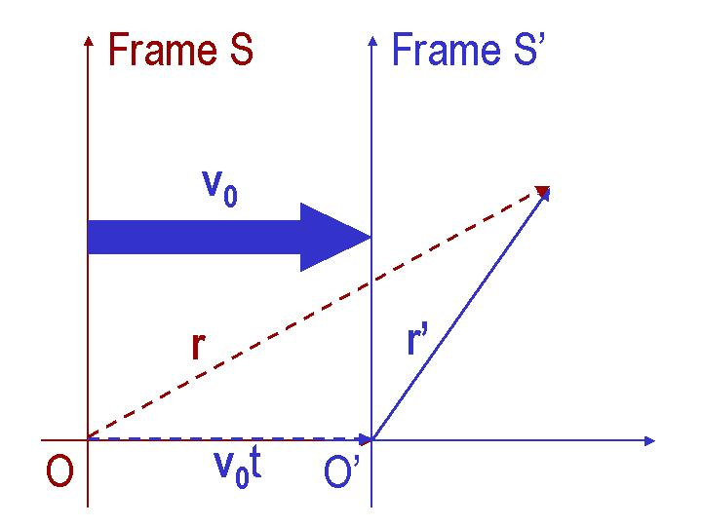
Solution: Since the river is moving at a constant velocity with respect to bank, the river and the bank are inertial frames. Therefore the position vector of the boat on the river and the bank reference frames are related as shown in the figure. This can be written mathematically as follows: $\vec{r}=\vec{v_{0}}t+\vec{r^{'}}$. From this equation one can deduce the relationship between acceleration of the boat measured on the bank and the river as follows; $\vec{v}=\frac{d\vec{r}}{\text{dt}}=\vec{v_{0}}+\frac{d\vec{r'}}{\text{dt}}=\vec{v_{0}}+\vec{v'}$ and $\vec{a}=\frac{d\vec{v}}{\text{dt}}=\frac{d}{\text{dt}}\left(\vec{v_{0}}+\frac{d\vec{r'}}{\text{dt}}\right)=\frac{d\vec{v'}}{\text{dt}}=\vec{a'}$. Thus the two measured accelerations are the same. This means that the accelerations measured on two inertial frames are the identical. Further extending the principle, one physical law valid in one inertial frame is also valid in another inertial frame.
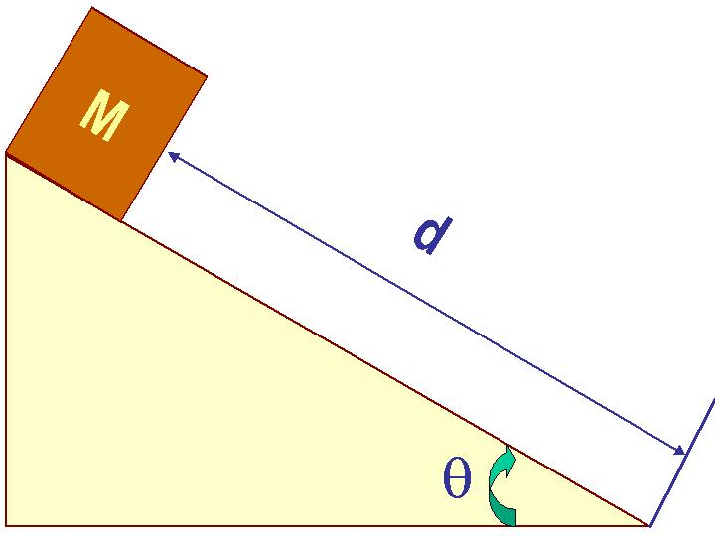
[ 5 – 33 points] A cart of mass M was released at the top of an incline of length d on Earth whose gravitational acceleration is g, as shown in the figure. The surface of the incline is rough. Its static friction coefficient is μ_{s}, and its kinetic friction coefficient is μ_{k}. The cart started moving at an angle θ.

- Which direction is the gravitational acceleration in this motion (2 points)?
Solution: The gravitational acceleration is always downward, toward the center of the Earth, no matter what the motion is like. So the answer is 2.
1. Along the incline 2. Downward
3. There is no gravitational acceleration 4. None of the above
- What are the forces exerting on the cart? (2 points)
Solution: There is a gravitational force. Since the cart is not falling through the incline, there must be a force balancing the weight or gravitational force on the cart, the normal force. In addition, the problem says that the surface of the incline is rough. Therefore there must be friction force exerting on the cart as well. So the answer is 3.
  - No force on this cart other than its motion
  - Gravitational and frictional forces
  - Gravitational, frictional and normal forces
  - None of the above
- Draw a free body diagram for the motion while the cart is moving. (4 points)

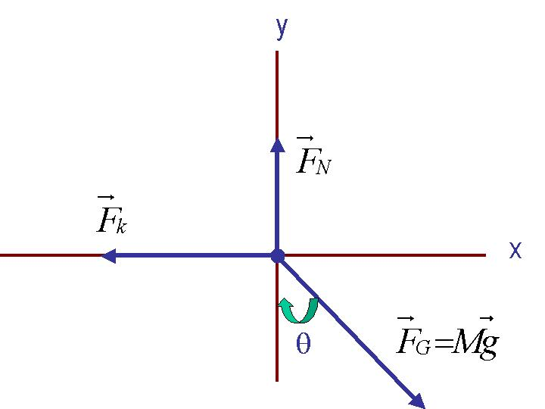
Solution: Since the cart is moving along the incline, it is a good idea to draw one of the axis of the reference frame along the direction of motion. In addition, since the cart is moving among the three forces in problem b), the friction force must be a kinetic friction, F_{k}. Using these two, one can draw the free body diagram of the moving cart as shown on the right.

- Write down the net force equation and each component of the net force. (6 points)
Solution: Based on the forces on the free body diagram in the previous problem, one can write the net force question as follows:
$\sum{\vec{F}=\vec{F_{G}}+}\vec{F_{N}}+\vec{F_{k}}=M\vec{a}$
from this equation one can write x and y components of the net force $F_{x}=\text{Mg}\text{sin}θ−F_{k}=\text{Mg}\text{sin}θ−μ_{k}F_{N}=\text{Ma}$
and
$F_{y}=F_{N}−\text{Mg}\text{cos}θ=0$. From the y component, one can deduce that $F_{N}=\text{Mg}\text{cos}θ$. Therefore the final answers to the question are $F_{x}=\text{Mg}\left(\text{sin}θ−μ_{k}\text{cos}θ\right)=\text{Ma}$
and
$F_{y}=F_{N}−\text{Mg}\text{cos}θ=0$.

- What is the magnitude of the static friction force just before the cart starts moving and the kinetic friction force while it is moving (6 points)?
Solution: Using the normal force from the previous equation, one can obtain kinetic friction force:
$F_{k}=μ_{k}F_{N}=μ_{k}\text{Mg}\text{cos}θ$
and static friction force:
$F_{s}≤μ_{s}F_{N}=μ_{s}\text{Mg}\text{cos}θ$

- Which of the following is the correct relationship between static frictional coefficient, μ_{s}, and the inclination angle θ? (3 points)
Solution: Since the cart starts moving when the angle become larger than the time the static friction and the x component of the gravitational forces become the same. This condition is met when the x component of the net force is 0, $F_{x}=\text{Mg}\left(\text{sin}θ−μ_{s}\text{cos}θ\right)=0$. Thus the correct expression of the critical angle is 1.
1. $θ={\text{tan}}^{−1}\left(μ_{s}\right)$ 2. $θ={\text{cos}}^{−1}\left(μ_{s}\right)$
3. $θ={\text{sin}}^{−1}\left(μ_{s}\right)$ 4. None of the above

- How long does it take for the cart to reach the bottom of the incline? (5 points)
Solution: Using the net force equation, the acceleration of this motion is $a=g\left(\text{sin}θ−μ_{k}\text{cos}θ\right)$. We also know that the initial velocity is 0. Therefore one can obtain the distance for the cart to reach at a certain time t as$x=d=\frac{1}{2}{\text{at}}^{2}$. Thus, the time it takes for the cart to reach the bottom of the hill is $t=\sqrt{\frac{2d}{a}}=\sqrt{\frac{2d}{g\left(\text{sin}θ−μ_{k}\text{cos}θ\right)}}$.

- What is the speed of the cart when it reaches the bottom of the incline? (5 points)
Solution: Since the time and the acceleration are known from the previous problems, one can obtain speed at which the cart will have at the bottom of the hill using kinematic equation of motions: $v=\text{at}=g\left(\text{sin}θ−μ_{k}\text{cos}θ\right)\sqrt{\frac{2d}{g\left(\text{sin}θ−μ_{k}\text{cos}θ\right)}}=\sqrt{2\text{dg}\left(\text{sin}θ−μ_{k}\text{cos}θ\right)}$.

Useful Formulae and information
Velocity: $\vec{v_{f}}=\vec{v_{i}}+\vec{a}t$
Position: $\vec{r_{f}}=\vec{r_{i}}+\vec{v_{i}}t+\frac{1}{2}\vec{a}t^{2}$
Newton’s universal law of gravitation: The gravitational force between the two objects of masses m1 and m2 is proportional to their masses and inversely proportional to the square of the distance between them.
$$F_{G}=\frac{{\text{Gm}}_{1}m_{2}}{r^{2}}$$
The solutions for a 2-dimensional equation:

$${\text{ax}}^{2}+\text{bx}+c=0$$
are:

$x=\frac{−b±\sqrt{b^{2}−4\text{ac}}}{2a}$

