Name:
ID:

[ 1 – 3 points] If the acceleration, a, of a particle moving with uniform speed, v, in a circle of radius, r, is proportional to some power of r, say r^{m}, and some power of v, say v^{n}. What are the correct values of m and n? Assume that a=k r^{m} v^{n}, where k is a dimensionless constant. Use dimensional analysis to find the answer.

- n=2, m=3 2. n=-1, m=2
3. n=2, m=-1 4. None of the above

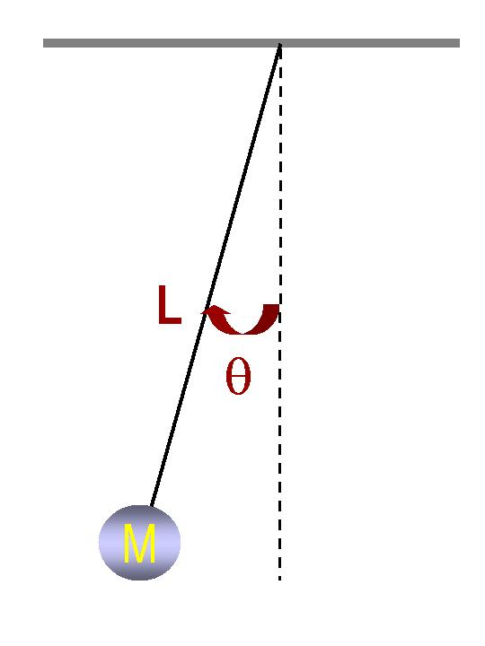
[ 2 – 15 points] A ball of mass M is tied to a massless string of length L and is swinging under the influence of Earth’s gravitational field, as shown in the figure. Answer the following series of questions.

- What is the radial acceleration at the time when the ball’s speed is v and the angle
is θ as shown in the figure above (3 points)?
1. $a_{r}=g\text{sin}θ$ 2. $a_{r}=g\text{cos}θ$
3. $a_{r}=\frac{v^{2}}{r}$ 4. None of the above
- What is the tangential acceleration at the time when the ball’s speed is v and the angle is θ (3 points)?
1. $a_{t}=g\text{sin}θ$ 2. $a_{t}=g\text{cos}θ$
3. $a_{t}=\frac{v^{2}}{r}$ 4. None of the above
- How does the speed of the ball depend on mass (3 points)?
1. It depends on M² 2. It depends on M
3. It does not depend on M 4. None of the above

- What is the total acceleration vector when the ball’s speed v is 2.0m/s, the angle θ is 30 degrees, and the gravitational acceleration g is 9.8m/s² (6 points)?

[ 3 – 27 points] •A bomber, flying straight horizontally, dropped a bomb whose Earth mass is 100kg on a target on a planet P whose mass is twice that of the Earth. When the bomber dropped the bomb, it was flying at the speed of mach 2 at a height of 10,000 feet. (Mach is the unit of speed of sound in air and is 340m/s). The magnitude of the Earth’s gravitational acceleration is g=9.80m/s². Assume ground is at y=0 and no air resistance. Use the Newton’s universal law of gravitation given at the end.

- What is the height of the bomber in SI unit (3 points)?
  - 3.05km 2. 3.05x10³ m
3. 3.05x10⁵ cm 4. 3.33x10³ yards
- What is the mass of the bomb on the planet P (3 points)?
  - 200kg 2. 100kg
3. 150kg 4. None of the above
- What are the forces involved in this motion? (3 points)
  - Gravitational force only
  - Gravitational, Tangential, and Radial forces
  - Radial, Frictional, and Tangential forces
  - None of the above
- What is the magnitude of the gravitational force exerting on this bomb by the planet? (3 points)
1. 490 N 2. 980N
3. 19.6x10² N 4. None of the above
- Where is the reaction force by the bomb exerting on (3 points)?
  - Itself 2. On the surface of the Earth
3. On the Planet P 4. There is no reaction force in this motion
- Which direction is the gravitational acceleration exerting on the bomb on the planet P? (3 points)
1. Downward
2. Horizontal
3. Horizontal when flying straight and down when coming down
4. None of the above
- What is each acceleration component? ( 3 points)
1. $a_{x}=0\text{.}0m/{s^{2}}$ and $a_{y}=−9\text{.}8m/{s^{2}}$
2. $a_{x}=4\text{.}\text{90}m/{s^{2}}$ and $a_{y}=8\text{.}\text{49}m/{s^{2}}$
3. $a_{x}=0m/{s^{2}}$ and $a_{y}=−\text{19}\text{.}6m/{s^{2}}$
4. $a_{x}=0m/{s^{2}}$ and $a_{y}=9\text{.}\text{80}m/{s^{2}}$
- How long did it take for the bomb to hit the target? (3 points)
1. $\text{19}\text{.}8s$ 2. $\text{17}\text{.}6s$
3. $\text{24}\text{.}9s$ 4. None of the above
- How far was the target away from the initial position when the bomber dropped the bomb? ( 3 points)
1. $\text{12}\text{.}0x{\text{10}}^{3}m$ 2. $\text{16}\text{.}9\text{km}$
3. $\text{680}m$ 4. None of the above
[ 4 – 22 points] A boat of mass 500kg, heading due East with a constant speed 25.0km/h, is crossing the river whose stream has a uniform speed of 5.0km/h due North.

- Determine the velocity of the boat seen by the observer on the bank. Express the velocity in its magnitude and angle. (4 points each, 8 points total)

- The width of the river is 10.0km. How long does it take for the boat to cross the river? (4 points)

- Show that the boat’s acceleration, a, (if it had been accelerating) measured on the bank is the same as that measured on the river and explain what this means. (10 points)
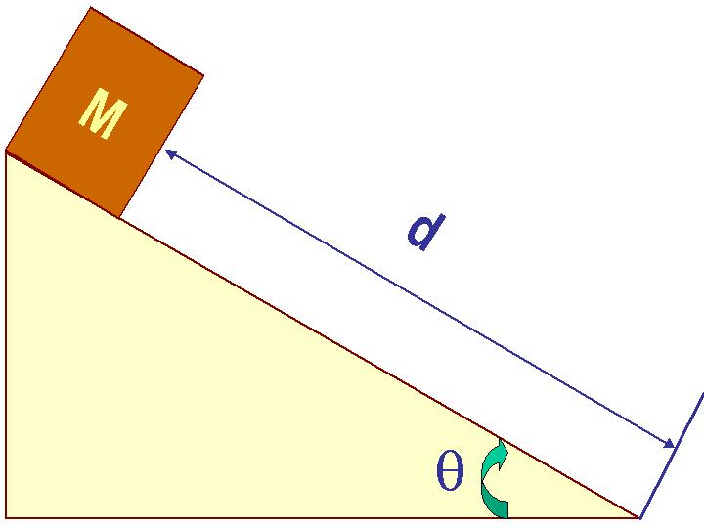
[ 5 – 33 points] A cart of mass M was released at the top of an incline of length d on Earth whose gravitational acceleration is g, as shown in the figure. The surface of the incline is rough. Its static friction coefficient is μ_{s}, and its kinetic friction coefficient is μ_{k}. The cart started moving at an angle θ.

- Which direction is the gravitational acceleration in this motion (2 points)?
1. Along the incline 2. Downward
3. There is no gravitational acceleration 4. None of the above
- What are the forces exerting on the cart? (2 points)
  - No force on this cart other than its motion
  - Gravitational and frictional forces
  - Gravitational, frictional and normal forces
  - None of the above
- Draw a free body diagram for the motion while the cart is moving. (4 points)

- Write down the net force equation and each component of the net force. (6 points)

- What is the magnitude of the static friction force just before the cart starts moving and the kinetic friction force while it is moving (6 points)?

- Which of the following is the correct relationship between static frictional coefficient, μ_{s}, and the inclination angle θ? (3 points)
1. $θ={\text{tan}}^{−1}\left(μ_{s}\right)$ 2. $θ={\text{cos}}^{−1}\left(μ_{s}\right)$
3. $θ={\text{sin}}^{−1}\left(μ_{s}\right)$ 4. None of the above
- How long does it take for the cart to reach the bottom of the incline? (5 points)

- What is the speed of the cart when it reaches the bottom of the incline? (5 points)

Useful Formulae and information
Velocity: $\vec{v_{f}}=\vec{v_{i}}+\vec{a}t$
Position: $\vec{r_{f}}=\vec{r_{i}}+\vec{v_{i}}t+\frac{1}{2}\vec{a}t^{2}$
Newton’s universal law of gravitation: The gravitational force between the two objects of masses m1 and m2 is proportional to their masses and inversely proportional to the square of the distance between them.
$$F_{G}=\frac{{\text{Gm}}_{1}m_{2}}{r^{2}}$$
The solutions for a 2-dimensional equation:

$${\text{ax}}^{2}+\text{bx}+c=0$$
are:

$x=\frac{−b±\sqrt{b^{2}−4\text{ac}}}{2a}$

