Name:
ID:

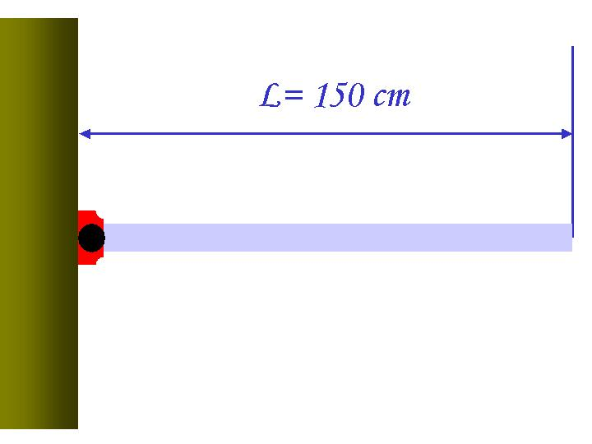
[ 1 – 20 points] A uniform rod of length 150 cm and mass 900g is attached at one end to a frictionless pivot and is free to rotate about the pivot in the vertical plane, as shown in the figure. Answer the following series of questions, assuming that the rod is released from rest in the horizontal position, and the magnitude of the gravitational acceleration g is $9\text{.}\text{80}m/{s^{2}}$.

- What is the line density of the rod?
1. 6.00kg/cm³ 2. 0.600kg/m
3. 0.600kg/cm 4. 6.00kg/m³

- What is the moment of inertia of the rod in this motion?
1. $0\text{.}\text{267}\text{kg}⋅m^{2}$ 2. $1\text{.}\text{35}\text{kg}⋅m$
3. $1\text{.}\text{35}\text{kg}⋅m^{2}$ 4. $0\text{.}\text{675}\text{kg}⋅m^{2}$

- What is the potential energy of the rod before the release?
1. $\text{13}\text{.}2{\text{kg}⋅m}/{s^{2}}$ 2. $\text{13}\text{.}2J$
3. $6\text{.}\text{62}J$ 4. $\text{mgh}$

- What is the angular speed of the rod when the rod reaches the bottom?
1. $4\text{.}{\text{43}}/s$ 2. $3\text{.}{\text{38}}/s$
3. $6\text{.}\text{62}m/s$ 4. $\text{16}\text{.}3/s$

- What is the linear speed of the center of mass when the rod is at its vertical position?
1. $7\text{.}\text{66}m/s$ 2. $3\text{.}\text{32}m/s$
3. $6\text{.}{\text{64}}/s$ 4. $3\text{.}{\text{38}}/s$

- What is the linear speed of the lowest point of the rod when the rod is in its vertical position?
1. $6\text{.}\text{65}m/s$ 2. $2\text{.}{\text{33}}/s$
3. $6\text{.}{\text{78}}/s$ 4. $3\text{.}\text{32}m/s$

- What is the magnitude of torque?
1. $9\text{.}8N$ 2. $3\text{.}\text{96}N⋅m$
3. $6\text{.}\text{62}N⋅m$ 4. $\text{12}\text{.}3N⋅m$

- What is the direction of torque in this motion?
1. Upward 2. Out of the page
3. Into the page 4. Downward

- What is the angular momentum of the rod when it is at its vertical position?
1. $2\text{.}\text{99}{\text{kg}⋅m^{2}}/s$ 2. $3\text{.}\text{23}{\text{kg}⋅m}/s$
3. $9\text{.}\text{80}{\text{kg}⋅m}/{s^{2}}$ 4. $6\text{.}\text{00}{\text{kg}⋅m^{2}}/s$
- What is the direction of angular momentum in this motion?
1. Upward 2. Out of the page
3. Into the page 4. Downward

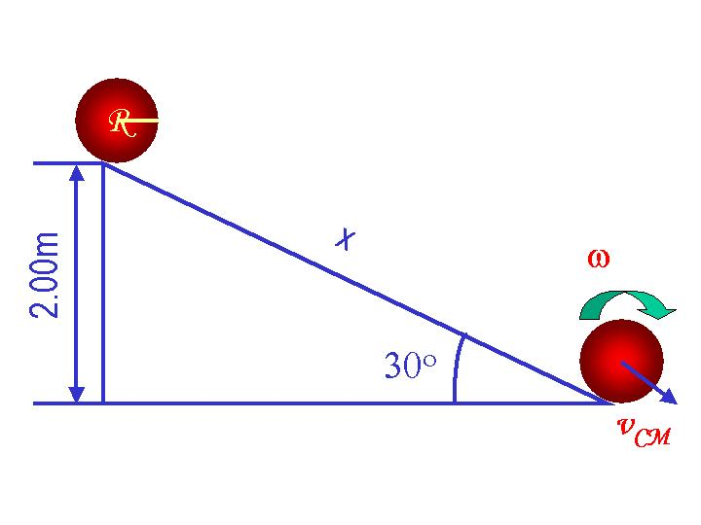
[ 2 – 25 points] •A solid sphere of mass 1.00kg and radius R=50.0cm was released at the top of the incline from rest, as shown in the picture, and is rolling down the incline without slipping. . The magnitude of the gravitational acceleration is g=9.8m/s². The surface of the incline has friction. Answer the following series of questions.

- What are the forces involved in this motion? (3 points)
  - Gravitational, Tangential, and Radial forces
  - Radial, Frictional, and Tangential forces
  - Gravitational force only
  - Gravitational, Frictional, and normal forces
- What is the condition for the sphere to undergo a “pure rolling” motion? (4points)
1. $\vec{F}=m\vec{a}$ 2. $τ=Iα$ 3. $v_{\text{CM}}=Rϖ$ 4. $\frac{1}{2}{\text{mv}}_{\text{CM}}^{2}=\text{mgh}$
- What is the magnitude of the gravitational force acting on the direction of sphere’s movement. (2 points)
1. 49.0 N 2. 4.90N
3. 9.80N 4. 98.0N
- Which direction is the gravitational acceleration in this motion? (2 points)
1. 30o upward to horizontal direction
2. Downward
3. Horizontal direction
4. Up before the middle of the incline and down past the middle
- What is the potential energy of the sphere before it is released, ignoring the radius of the sphere? ( 2 points)
1. $9\text{.}\text{80}J$ 2. $\text{19}\text{.}6J$
3. $\text{39}\text{.}2J$ 4. $\text{19}\text{.}6{\text{kg}⋅m}/{s^{2}}$
- What is the linear velocity of the center of mass of the sphere at the bottom of the incline? Use the moment of inertia of a solid sphere given in the formula. (4 points)
1. $\text{28}\text{.}0m/s$ 2. $5\text{.}\text{29}m/s$
3. $\text{39}\text{.}2m/s$ 4. $6\text{.}\text{26}m/s$

- What is the angular speed of the sphere at the bottom of the incline? ( 4 points)
1. $5\text{.}\text{30}m/s$ 2. $0\text{.}{\text{106}}/{\text{sm}}$
3. $2\text{.}{\text{79}}/s$ 4. $\text{10}\text{.}6/s$
- What is the total energy of the sphere at the bottom of the hill? ( 4 points)
1. $\text{14}\text{.}0J$ 2. $5\text{.}\text{62}J$
3. $\text{39}\text{.}2J$ 4. $\text{19}\text{.}6J$
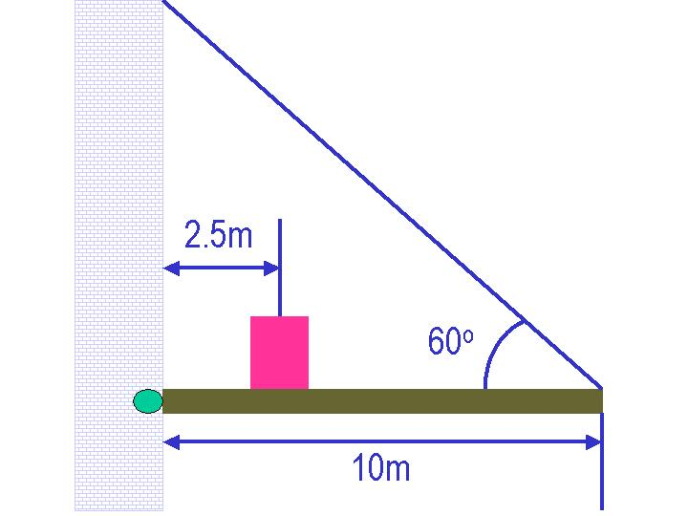
[ 3 – 20 points] A box of mass 75kg, is put on a steel beam of mass 150kg which is connected to the wall by a frictionless pivot and is supported by a steel cable as shown in the figure. Assuming that the entire system is at its equilibrium, and the gravitational acceleration is g=9.8m/s², answer the following series of questions.

- What are the weights of the box and the steel beam? (2 points each)

- Draw a free body diagram and write down the net force components and the net torque involved in this system. (8 points)

- What is the magnitude of the tension on the cable required to keep the system balanced? (3 points)

- What are the magnitude and the direction of the force exerted by the wall on the beam? (5 points)
[ 4 – 18 points] An object of mass 500g is undergoing a motion along the x-axis without friction. Its displacement from the origin varies with time according to the equation;
$$x=−\left(3\text{.}\text{50}m\right)\text{sin}\left(0\text{.}5πt+\frac{5π}{4}\right)$$
where t time is in seconds, and the angles in the parentheses are in radians. Answer the following questions

- What kind of motion is this?
1. Simple motion 2. Free Fall
3. Harmonic Oscillation 4. Perfect motion

- What is the amplitude of this motion?
1.3.5m 2. 2πm 3.3.5πm 4. 7.0πm/s

- What is the period of this motion?
1. 4.00s 2. 2.00/s 3. 4.00/s 4. 2.00s

- What is the frequency of this motion?
1. 0.25s 2. 0.50/s 3. 0.25/s 4. 2.00s
- What is the linear velocity of the motion?
1. $v=−\left(3\text{.}\text{50}\right)\text{cos}\left(0\text{.}5πt+\frac{5π}{4}\right)m/s$ 2. $v=−\left(1\text{.}\text{75}π\right)\text{cos}\left(0\text{.}5πt+\frac{5π}{4}\right)m/s$
3. $v=−\left(1\text{.}\text{75}π\right)\text{sin}\left(0\text{.}5πt+\frac{5π}{4}\right)m/s$ 4. $v=\left(1\text{.}\text{75}π\right)\text{cos}\left(0\text{.}5πt+\frac{5π}{4}\right)m/s$
- What is the linear acceleration of the motion?
1. $a=\left(3\text{.}\text{50}π^{2}\right)\text{sin}\left(0\text{.}5πt+\frac{5π}{4}\right)m/{s^{2}}$ 2. $a=−\left(0\text{.}\text{88}π^{2}\right)\text{cos}\left(0\text{.}5πt+\frac{5π}{4}\right)m/{s^{2}}$
3. $a=\left(0\text{.}\text{88}π^{2}\right)\text{sin}\left(0\text{.}5πt+\frac{5π}{4}\right)m/{s^{2}}$ 4. $a=−\left(3\text{.}\text{50}π^{2}\right)\text{cos}\left(0\text{.}5πt+\frac{5π}{4}\right)m/{s^{2}}$
- What is maximum kinetic energy of the system?
1. $K_{\text{Max}}=7\text{.}\text{56}J$ 2. $K_{\text{Max}}=\text{74}\text{.}8J$
3. $K_{\text{Max}}=3\text{.}\text{06}J$ 4. $K_{\text{Max}}=8\text{.}\text{64}J$
- What is maximum potential energy of the system?
1. $U_{\text{Max}}=7\text{.}\text{56}J$ 2. $U_{\text{Max}}=\text{74}\text{.}8J$
3. $U_{\text{Max}}=3\text{.}\text{06}J$ 4. $U_{\text{Max}}=8\text{.}\text{64}J$
- What is total mechanical energy of the system?
1. $E=7\text{.}\text{56}J$ 2. $E=\text{15}\text{.}2J$
3. $E=3\text{.}\text{06}J$ 4. $E=\text{17}\text{.}3J$
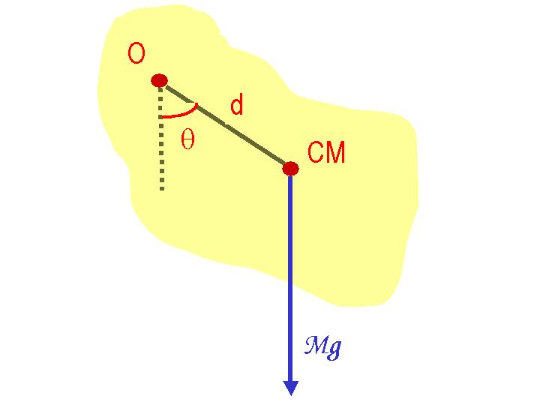
[5 – 17 points]A rigid object of mass M is pivoted at the point O. The pivot O is a distance d away from the center of mass of the object, as shown in the figure. Answer the following series of questions, assuming the gravitational acceleration is g and is uniform throughout the body of the object, and the moment of inertia for this object is I, and the angle θ is sufficiently small.

- Show that this motion satisfies the conditions for a simple harmonic oscillation. (5 points)

- What is the period, T, of this motion in terms of known quantities, m, g, d, θ, and I?. (5 points)

- Show that this formula for period is also valid for simple pendulum where the bob of mass m is hanging at the end of massless string of length L, starting at a small angle θ with respect to its vertical position. (7 points)
Useful Formulae
Velocity: $\vec{v_{f}}=\vec{v_{i}}+\vec{a}t$
Position: $\vec{r_{f}}=\vec{r_{i}}+\vec{v_{i}}t+\frac{1}{2}\vec{a}t^{2}$
Center of Mass: $\vec{r_{\text{CM}}}=\frac{\sum{m_{i}\vec{r_{i}}}}{\sum{m_{i}}}$
Linear Speed: $v=rϖ$ where ω is an angular speed
Linear Acceleration: $a=rα$ where α is an angular acceleration
Linear Momentum: $\vec{p}=m\vec{v}$
Kinetic Energy: $K=\frac{1}{2}{\text{mv}}^{2}$
Gravitational Potential Energy: $U=\text{mgh}$
Moment of Inertia: $I=\int{r^{2}\text{dm}}$
Moment of Inertia of a Solid Sphere with mass M and radius R: $I=\frac{2}{5}{\text{MR}}^{2}$
Torque: $τ=\text{Fd}=Iα$ where d is moment arm and α is the angular acceleration
Rotational Kinetic Energy: $K_{R}=\frac{1}{2}{Iω}^{2}$
Angular Momentum: $\begin{aligned}\vec{L}=\vec{r}×\vec{p} \\ \left|L\right|=Iϖ\end{aligned}$
The solutions for a 2-dimensional equation:

$${\text{ax}}^{2}+\text{bx}+c=0$$
are:

$x=\frac{−b±\sqrt{b^{2}−4\text{ac}}}{2a}$

