Name:
ID:

[ 1 – 28 points] •An object whose mass is 1.50kg on the surface of the Earth is undergoing a projectile motion on the surface of a planet P whose mass (M_{p}) is half that of the Earth (M_{E}). The object is thrown upward from the top of a building at an angle of 30o to horizontal with initial speed of 30.0m/s. The height of the building is 20.0m, and there is no air on the planet. The magnitude of the Earth’s gravitational acceleration is g=9.8m/s². Answer the following questions, assuming the top of the building is at y=0, and upward is +y direction.

- What are the forces involved in this motion? (2 points)
  - Planet force
  - Gravitational force
  - Radial, Frictional, and gravitational forces
  - Gravitational, Tangential, and Radial forces

- What is the mass of the object on the surface of the planet (2 points)?
1. 1.5 kg 2. 0.75kg
3. 3.0kg 4. 14.7kg

- What is weight of the object on the surface of the planet? (2 points)
1. 1.5 N 2. 14.7kg m/s²
3. 7.35N 4. 12.7N

- Which direction is the gravitational acceleration on this planet? (2 points)
1. 30o upward to horizontal in the direction of the movement
2. Downward to the center of the planet
3. 30o upward when going up and 30o downward when coming down
4. Upward toward the Earth

- What is each acceleration component on this planet? ( 2 points)
1. $a_{x}=4\text{.}\text{90}m/{s^{2}}$ and $a_{y}=−8\text{.}\text{49}m/{s^{2}}$
2. $a_{x}=4\text{.}\text{90}m/{s^{2}}$ and $a_{y}=8\text{.}\text{49}m/{s^{2}}$
3. $a_{x}=0m/{s^{2}}$ and $a_{y}=−9\text{.}\text{80}m/{s^{2}}$
4. $a_{x}=0m/{s^{2}}$ and $a_{y}=−4\text{.}\text{90}m/{s^{2}}$

- What is the potential energy of the object at the top of the building? ( 3 points)
1. $0J$ 2. $\text{294}J$
3. $\text{212}W$ 4. $\text{147}J$

- How long does it take for the object to reach its maximum height? ( 3 points)
1. $2\text{.}\text{39}s$ 2. $3\text{.}\text{06}s$
3. $1\text{.}\text{53}s$ 4. $1\text{.}\text{00}s$
- How long would it take for the object to hit the surface of the planet? (3 points)
1. $9\text{.}8s$ 2. $7\text{.}\text{26}s$
3. $\text{14}\text{.}3s$ 4. $6\text{.}\text{12}s$

- How far is the object away from the initial position when it hits the surface of the planet? ( 3 points)
1. $\text{372}m$ 2. $\text{94}m$
3. $\text{188}m$ 4. $\text{159}m$

- What is the coordinate of the maximum height the object would reach? ( 3 points)
1. $\text{11}\text{.}5m$ 2. $\text{31}\text{.}5m$
3. $\text{43}\text{.}0m$ 4. $\text{23}\text{.}0m$

- What is the kinetic energy of the object just before it hits the surface of the planet? ( 3 points)
1. $\text{822}J$ 2. $\text{969}J$
3. $\text{1240}J$ 4. $\text{294}J$
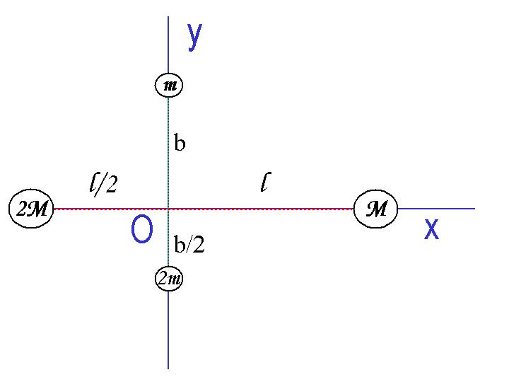
[2– 25 points]Answer the following questions in a system consists of four small spheres as shown in the figure, assuming the radii are negligible and the rods connecting the spheres are massless.
- Determine the coordinate of the Center of Mass of the system. (5points)

- Compute the moment of inertia and the rotational kinetic energy when the system rotates clockwise about the x-axis at the angular speed ω. (5 points each)

c) Compute the moment of inertia, using parallel axis theorem, and the rotational kinetic energy when the system is rotating clockwise about the z axis at the angular speed ω. (5 points each)
[ 3– 25 points] The motion of a random point on a sinusoidal wave is expressed as:
$$y=\left(1\text{.}\text{50}\right)\text{cos}\left(\frac{2π}{0\text{.}\text{500}}x+\text{16}\text{.}0πt\right)m$$
The mass of the string is 500g, and its length is 2.5m.

a) What kind of wave does this equation of motion represent (2 points)?
1. Standing wave 2. Free Fall
3. Harmonic Oscillation 4. Traveling wave
b) What is the wavelength of this wave (2 points)?
1. 1.5m 2. 2π/0.50m 3.0.50m 4. 16π m/s

c) What is the frequency of this motion (2 points)?
1. 2π/0.50s 2. 8.00/s 3. 16/s 4. 16π s

d) What is the maximum amplitude of this motion (2 points)?
1. 1.50cm 2. 3.00m 3. 1.50m 4. 16πm
e) What is the transverse speed of the point (2 points)?
1. $v_{y}=\left(−\text{24}\text{.}0π\right)\text{sin}\left(\frac{2π}{0\text{.}\text{500}}x+\text{16}\text{.}0πt\right)m/s$
2. $v_{y}=\left(−6π\right)\text{sin}\left(\frac{2π}{0\text{.}\text{500}}x+\text{16}\text{.}0πt\right)m/s$
3. $v_{y}=\left(−1\text{.}5\right)\text{sin}{\left(\frac{2π}{0\text{.}\text{500}}x+\text{16}\text{.}0πt\right)}/s$
4.$v_{y}=\left(\text{24}\text{.}0π\right)\text{cos}\left(\frac{2π}{0\text{.}\text{500}}x+\text{16}\text{.}0πt\right)m/s$
f) What is the transverse acceleration of the point (2 points)?
1. $a_{y}=\left(−\text{24}\text{.}0π\right)\text{cos}\left(\frac{2π}{0\text{.}\text{500}}x+\text{16}\text{.}0πt\right)m/s$
2. $a_{y}=\left(−\text{384}π^{2}\right)\text{cos}\left(\frac{2π}{0\text{.}\text{500}}x+\text{16}\text{.}0πt\right)m/{s^{2}}$
3. $a_{y}=\left(−\text{36}\text{.}0π\right)\text{cos}\left(\frac{2π}{0\text{.}\text{500}}x+\text{16}\text{.}0πt\right)m/{s^{2}}$
4. $a_{y}=\left(\text{24}\text{.}0π\right)\text{sin}\left(\frac{2π}{0\text{.}\text{500}}x+\text{16}\text{.}0πt\right)m/s$
g) What is the angular wave number (2 points)?
1. $k=\text{16}πm$ 2. $k=\text{16}π/m$
3. $k={\frac{2π}{0\text{.}\text{500}}}/m$ 4. $k=\frac{2π}{0\text{.}\text{500}}m$
h) What is speed of the wave (3 points)?
1. $v=4\text{.}\text{00}m/s$ 2. $v=\text{16}{πm}/s$
3. $v=\frac{2π}{0\text{.}\text{500}}s/m$ 4. $v=8\text{.}\text{00}m/s$
i) What is the line density of the string (2 points)?
1. 0.500kg/m 2. 1.00kg/m 3. 0.200kg/m 4.3.00kg
j) What is the power supplied by the tension on the string to keep this motion (3 points)?
1. $P=\text{512}W$ 2. $P=\text{2490}W$
3. $P=\text{2274}W$ 4. $P=\text{2747}J$
k) What is the total energy put into the system to sustain this wave for 10 seconds (3 points)?
1. $E=2\text{.}\text{49}×{\text{10}}^{4}J$ 2. $E=2\text{.}\text{27}×{\text{10}}^{4}J$
3. $E=5\text{.}\text{12}×{\text{10}}^{3}J$ 4. $E=2\text{.}\text{75}×{\text{10}}^{4}J$
[4– 22 points]After a storm the water level at the Hoover dam on planet K, whose mass is twice that of the Earth, is reaching to a height of 50m. The gravitational acceleration on the surface of the Earth is 9.8m/s². The density of water is $ρ=1\text{.}\text{00}×{\text{10}}^{3}{\text{kg}}/{m^{3}}$. Width of the dam is 250m. Answer the following questions.
- Determine the pressure exerted on the dam at 20m from the surface of the water, ignoring the air pressure. (5points)

- Determine the total force exerted on the dam by the water. (7 points)

- Assuming the width of the dam is constant throughout the entire height of the dam, design a dam that can hold the water and explain why you designed the dam the way you did. (10 points)

Useful Formulae
Velocity: $\vec{v_{f}}=\vec{v_{i}}+\vec{a}t$
Position: $\vec{r_{f}}=\vec{r_{i}}+\vec{v_{i}}t+\frac{1}{2}\vec{a}t^{2}$
Center of Mass: $\vec{r_{\text{CM}}}=\frac{\sum{m_{i}\vec{r_{i}}}}{\sum{m_{i}}}$
Linear Momentum: $\vec{p}=m\vec{v}$
Kinetic Energy: $K=\frac{1}{2}{\text{mv}}^{2}$
Moment of Inertia: $I=\int{r^{2}\text{dm}}$
Torque: $τ=\text{Fd}=Iα$ where d is moment arm and α is the angular acceleration
Rotational Kinetic Energy: $K_{R}=\frac{1}{2}{Iω}^{2}$
Angular Momentum: $\begin{aligned}\vec{L}=\vec{r}×\vec{p} \\ \left|L\right|=Iϖ\end{aligned}$
Gravitational force between two objects with masses M₁ and M₂ at the distance r is
$$F=\frac{{\text{GM}}_{1}M_{2}}{r^{2}}$$
Pressure exerted by a liquid of density ρ in the depth h is $P=ρ\text{gh}$
Energy transfer by a sinusoidal wave on a string is $P=\frac{1}{2}{\text{μω}}^{2}A^{2}v$where μ is the density of the string, ω is the angular frequency, A is the amplitude, and v is the speed of wave.

The solutions for a 2-dimensional equation:

$${\text{ax}}^{2}+\text{bx}+c=0$$
are:

$x=\frac{−b±\sqrt{b^{2}−4\text{ac}}}{2a}$

