Name:
ID:

[ 1 – 25 points] •A stone of mass 500g was thrown upward from the top of a building at an angle of 60o to horizontal with initial speed of 15.0m/s. The height of the building is 50.0m, and there is no air resistance. The magnitude of the gravitational acceleration is g=9.8m/s². Assume ground is at y=0.

- What are the forces involved in this motion? (2 points)
  - Gravitational, Tangential, and Radial forces
  - Radial, Frictional, and Tangential forces
  - Gravitational force only:
This is a projectile motion, and the gravitational force is the only force present in this motion.
  - Gravitational, Frictional, and Radial forces
- What is the magnitude of the gravitational force exerting on this stone? (2 points)
1. 49.0 N 2. 4.90N
Since the gravitational force F_{g}=Mg, =0.50x9.80=4.90N
3. 9.80N 4. 98.0N
- Which direction is the gravitational acceleration? (2 points)
1. 60o upward to horizontal
2. Horizontal
3. Up when going up and down when coming down
- Downward:
As all of you know very well, the gravitational acceleration is always downward, toward the center of the earth.
- What is each acceleration component? ( 2 points)
1. $a_{x}=4\text{.}\text{90}m/{s^{2}}$ and $a_{y}=−8\text{.}\text{49}m/{s^{2}}$
2. $a_{x}=4\text{.}\text{90}m/{s^{2}}$ and $a_{y}=8\text{.}\text{49}m/{s^{2}}$
3. $a_{x}=0m/{s^{2}}$ and $a_{y}=−9\text{.}\text{80}m/{s^{2}}$ : Since the gravitational acceleration is always downward there is no horizontal component. In addition, normally upward is defined as positive y, the sign of y component of the acceleration is negative. Therefore, 3 is the answer.
4. $a_{x}=0m/{s^{2}}$ and $a_{y}=9\text{.}\text{80}m/{s^{2}}$
- What is the potential energy of the stone at the top of the building? ( 3 points)
1. $0J$ 2. $\text{245}J$ Since gravitational potential energy V=Mgh, the size of potential energy is V=0.50x9.80x50.0=245J.
3. $\text{212}W$ 4. $\text{212}J$
- How long does it take for the stone to reach its maximum height? ( 3 points)
1. $2\text{.}\text{39}s$ 2. $2\text{.}\text{18}s$
3. $1\text{.}\text{33}s$ 4. $1\text{.}\text{00}s$
When the stone reaches at the highest point of the trajectory, the stone’s vertical velocity component must be 0 to turn around and start coming down. Therefore, from the formula, v_{y}=0=v_{yi}-gt. So $t=\frac{v_{\text{yi}}}{g}=\frac{v_{i}\text{sin}θ}{g}=\frac{\text{15}\text{.}0×\text{sin}{\text{60}}^{∘}}{9\text{.}\text{80}}=1\text{.}\text{33}s$.
- How long would it take for the stone to hit ground? (3 points)
1. $9\text{.}8s$ 2. $4\text{.}\text{79}s$
3. $4\text{.}\text{22}s$ 4. $\text{10}\text{.}0s$
When the stone reaches the ground, y component of the position is 0. From the formula,$y_{f}=0=y_{i}+v_{\text{iy}}t−\frac{1}{2}{\text{gt}}^{2}=\text{50}+\text{15}×\text{sin}{\text{60}}^{∘}t−\frac{9\text{.}8}{2}t^{2}\text{.}$ Solving this two-dimensional equation, one obtains two solutions of which only 4.79s makes physical sense.
- How far is the stone away from the initial position when it hits ground? ( 2 points)
1. $\text{35}\text{.}9m$ 2. $\text{15}\text{.}0m$
3. $\text{25}\text{.}2m$ 4. $\text{42}\text{.}2m$
Since the total flight time is of the stone is 4.79s, from the formula, one can obtain: $x_{f}=x_{i}+v_{\text{ix}}\text{cos}θt=0+\text{15}\text{.}0×\text{cos}{\text{60}}^{∘}×4\text{.}\text{79}=\text{35}\text{.}9m$
- What is the maximum height the stone would reach? ( 3 points)
1. $8\text{.}\text{60}m$ 2. $\text{35}\text{.}7m$
3. $\text{58}\text{.}6m$ 4. $\text{98}\text{.}0m$
Since the time it takes for the stone to reach the highest point is 1.33 s and the stone was fired from the top of the building at height 50.0m, from the formula, one can obtain: $y_{f}=y_{i}+v_{\text{iy}}t−\frac{1}{2}{\text{gt}}^{2}=\text{50}\text{.}0+\text{15}\text{.}0×\text{sin}{\text{60}}^{∘}×1\text{.}\text{33}−\frac{9\text{.}\text{80}}{2}×{\left(1\text{.}\text{33}\right)}^{2}=\text{58}\text{.}6m$
- What is the kinetic energy of the stone just before it hits the ground? ( 3 points)
1. $\text{279}J$ 2. $\text{245}J$
3. $\text{301}J$ 4. $\text{287}J$
Since the speed of the stone just before it hits the ground is:
$$\begin{aligned}v_{\text{fx}}=v_{\text{if}}=\text{15}\text{.}0×\text{cos}{\text{60}}^{∘}=7\text{.}\text{50}m/s \\ v_{\text{fy}}=v_{\text{iy}}−\text{gt}=\text{15}\text{.}0×\text{sin}{\text{60}}^{∘}−9\text{.}\text{80}×4\text{.}\text{79}=−\text{34}\text{.}0m/s \\ v_{f}=\sqrt{v_{\text{fx}}^{2}+v_{\text{fy}}^{2}}=\sqrt{{\left(7\text{.}5\right)}^{2}+{\left(−\text{34}\text{.}0\right)}^{2}}=\text{34}\text{.}8 \\ K=\frac{1}{2}{\text{Mv}}^{2}=\frac{1}{2}×0\text{.}5×{\left(\text{34}\text{.}8\right)}^{2}=\text{301}J\end{aligned}$$
It can be solved using conservation of mechanical energy:
$$E=K+V=\frac{1}{2}{\text{mv}}_{i}^{2}+\text{mgh}=\frac{1}{2}×0\text{.}5×{\text{15}}^{2}+0\text{.}5×9\text{.}8×\text{50}=\text{301}J$$
[ 2 – 15 points] A boat of mass 250kg, heading due south with a speed 20.0km/h is crossing the river whose stream has a uniform speed of 10.0km/h due east.

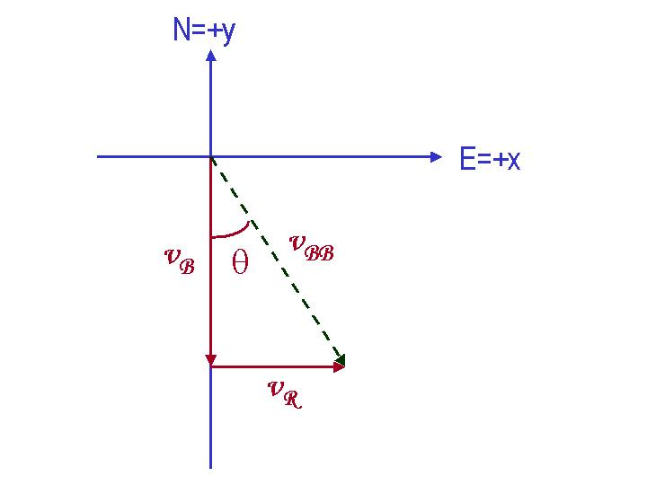
- Determine the velocity of the boat seen by the observer on the bank. Express the velocity in its magnitude and angle. (5 points)
$$v_{\text{BB}}=\sqrt{v_{B}^{2}+v_{R}^{2}}=\sqrt{\text{100}+\text{400}}=\text{22}\text{.}4{\text{km}}/h=6\text{.}\text{21}m/s$$
$$\text{tan}θ=\frac{v_{R}}{v_{B}}=\frac{\text{10}}{\text{20}}$$
$$θ={\text{tan}}^{−1}\left(\frac{\text{10}}{\text{20}}\right)=\text{26}\text{.}6^{∘}$$
Direction is 26.6º East with respect to South.

- What is the kinetic energy of the boat measured by the observer on the river? (5 points)
Since the problem asked for the kinetic energy of the boat measured by an observer on the river, the speed of the boat to this observer is v_{B}. Therefore, the kinetic energy of the boat measured by this observer is:
$$K=\frac{1}{2}{\text{mv}}_{\text{Bi}}^{2}=\frac{1}{2}×\text{250}×{\left(5\text{.}\text{56}\right)}^{2}=\text{3864}J$$
Note that the unit of the speed of the boat should be converted to m/s from km/h.

- The width of the river is 5.0km. How long does it take for the boat to cross the river? (5 points)
Since the length is on y-axis only, the component of the speed on y axis is the only quantity that matters. Therefore the time it takes for the boat to cross the river is
$$t=\frac{5}{\text{20}}\text{hours}=\text{15}\text{min}\text{utes}$$
[ 3 – 20 points] A car of mass m₁ stopped at a traffic light is rear-ended by a car with mass m₂ (<m₁), and the two become entangled. The lighter car was moving at v_{i} =30.0m/s before the collision.

- What kind of collision is this? (3 points)
1. Elastic Collision 2. Perfectly Inelastic Collision
3. Read-end Collision 4. Perfectly Elastic Collision
After the collision the two cars stuck to each other, forming one body. Therefore this collision is a “Perfectly Inelastic Collision.”
- What are the quantities conserved in this collision? (3 points)
  - Mechanical Energy and linear momentum
  - Kinetic energy only
  - Linear momentum only
  - Kinetic energy and linear momentum
In perfectly inelastic collision, only linear momentum is conserved.
- What is the velocity of the entangled cars after the collision in terms of masses m₁ and m₂, and the initial velocity of the lighter car, v_{i}? (4 points)
1.$v_{f}=\frac{m_{2}v_{i}}{m_{1}}$ 2. $v_{f}=\frac{m_{1}v_{i}+m_{2}v_{i}}{m_{1}+m_{2}}$
3. $v_{f}=\frac{m_{2}v_{i}}{m_{1}+m_{2}}$ 4. $v_{f}=\frac{m_{1}v_{i}}{m_{1}+m_{2}}$
From linear momentum conservation, the initial and final momentum of the system must be the same. Therefore:
Before collision:$P_{i1}+P_{2i}=m_{1}v_{1i}+m_{2}v_{2i}=m_{1}×0+m_{2}×v_{i}=m_{2}v_{i}$
After collision:$P_{1f}+P_{2f}=\left(m_{1}+m_{2}\right)v_{f}$
Therefore: $\left(m_{1}+m_{2}\right)v_{f}=m_{2}v_{i};v_{f}=\frac{m_{2}v_{i}}{\left(m_{1}+m_{2}\right)}$
- What are the initial kinetic energies of the two cars, if m₁=2500kg and m₂=1000kg? ( 3 points)
1. $\begin{aligned}\left\{K_{1}=\text{11}\text{.}3×{\text{10}}^{5}J | \right.\end{aligned}$ 2. $\begin{aligned}\left\{K_{1}=0J | \right.\end{aligned}$

3. $\begin{aligned}\left\{K_{1}=\text{11}\text{.}3×{\text{10}}^{5}J | \right.\end{aligned}$ 4. $\begin{aligned}\left\{K_{1}=\text{2500}J | \right.\end{aligned}$
Since initial speed of the car #1 is 0, its kinetic energy, K1, is 0J.
Since the speed of car #2 is 30m/s, and its mass is 1000kg, its kinetic energy is
$$K=\frac{1}{2}{\text{mv}}_{2}^{2}=\frac{1}{2}×\text{1000}×{\left(\text{30}\right)}^{2}=4\text{.}\text{50}×{\text{10}}^{5}J$$
- What are the initial linear momenta of the two cars? (3 points)
1. $\begin{aligned}\left\{p_{1}=7\text{.}\text{50}×{\text{10}}^{4}{\text{kg}⋅m}/s | \right.\end{aligned}$ 2. $\begin{aligned}\left\{p_{1}=7\text{.}\text{50}×{\text{10}}^{4}{\text{kg}⋅m}/s | \right.\end{aligned}$

3. $\begin{aligned}\left\{p_{1}=0\text{.}\text{00}{\text{kg}⋅m}/s | \right.\end{aligned}$ 4. $\begin{aligned}\left\{p_{1}=7\text{.}\text{50}×{\text{10}}^{4}J/s | \right.\end{aligned}$
Since initial speed of the car #1 is 0, its linear momentum, p1, is 0 kg.m/s.
Since the speed of car #2 is 30m/s, and its mass is 1000kg, its linear momentum is
$$p_{2}={\text{mv}}_{2}=\text{1000}×\text{20}=3\text{.}\text{00}×{\text{10}}^{4}{\text{kg}⋅m}/s$$
- What is the kinetic of the system after the collision? (4 points)
1. $K_{f}=1\text{.}\text{29}×{\text{10}}^{5}J$ 2. $K_{f}=\text{15}\text{.}3×{\text{10}}^{5}J$
3. $K_{f}=3\text{.}\text{50}×{\text{10}}^{4}J$ 4. $K_{f}=\text{11}\text{.}3×{\text{10}}^{5}J$
Since the speed of the system after the collision is
$$v_{f}=\frac{m_{2}v_{i}}{\left(m_{1}+m_{2}\right)}=\frac{\text{1000}}{\text{3500}}×\text{30}=8\text{.}\text{57}m/s$$
The kinetic energy of the system is
$$K=\frac{1}{2}\left(m_{1}+m_{2}\right)v_{f}^{2}=\frac{1}{2}×\text{3500}×{\left(8\text{.}\text{57}\right)}^{2}=1\text{.}\text{29}×{\text{10}}^{5}J$$
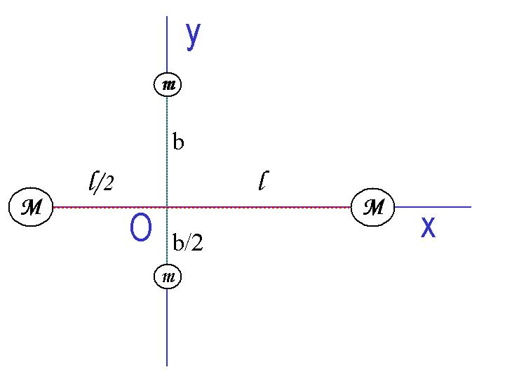
[4 – 20 points]Answer the following questions in a system consists of four small spheres as shown in the figure, assuming the radii are negligible and the rods connecting the spheres are massless.
- Determine the coordinate of the Center of Mass of the system. (5points)
Using the definition of the center of mass $\vec{r_{\text{CM}}}=\frac{\sum{m_{i}\vec{r_{i}}}}{\sum{m_{i}}}$
$$x_{\text{CM}}=\frac{\sum{m_{i}x_{i}}}{\sum{m_{i}}}=\frac{\text{Ml}−\frac{1}{2}\text{Ml}+m⋅0+m⋅0}{2\left(M+m\right)}=\frac{\text{Ml}}{4\left(M+m\right)}$$
$$y_{\text{CM}}=\frac{\sum{m_{i}y_{i}}}{\sum{m_{i}}}=\frac{\text{mb}−\frac{1}{2}\text{mb}+M⋅0+M⋅0}{2\left(M+m\right)}=\frac{\text{mb}}{4\left(M+m\right)}$$
Therefore the coordinate of the center of mass of the system is
$$\text{CM}=\left(\frac{\text{Ml}}{4\left(M+m\right)},\frac{\text{mb}}{4\left(M+m\right)}\right)$$
- Compute the moment of inertia and the rotational kinetic energy when the system rotates about the y-axis at ω. (10 points)
Moment of inertia of the system when the system rotates about y axis is
$$I=\int{r^{2}\text{dm}}={\text{Ml}}^{2}+M{\left(\frac{1}{2}l\right)}^{2}=\frac{5}{4}{\text{Ml}}^{2}$$

Thus, kinetic energy of the system is
$$K_{R}=\frac{1}{2}{Iω}^{2}=\frac{5}{8}{\text{Ml}}^{2}ϖ^{2}$$

- Compute the moment of inertia, using parallel axis theorem and the rotational kinetic energy when the system is rotating about the z axis at ω. (5 points)
Parallel axis theorem tells that moment of inertia of a system that rotates about any arbitrary axis can be written as a linear combination of the moment of inertia of the CM to that axis and the moment of inertial with respect to the CM;
$I=\sum{{\text{MD}}^{2}+I_{\text{CM}}}$, where D is the distance from the rotational axis to the CM.
Using the coordinate of the CM from previous problems one gets:
$$\begin{aligned}D=\sqrt{{\left(\frac{\text{Ml}}{4\left(M+m\right)}\right)}^{2}+{\left(\frac{\text{mb}}{4\left(M+m\right)}\right)}^{2}}=\frac{\sqrt{M^{2}l^{2}+m^{2}b^{2}}}{4\left(M+m\right)} \\ ∴\sum{{\text{MD}}^{2}}=2\left(M+m\right){\left(\frac{\sqrt{M^{2}l^{2}+m^{2}b^{2}}}{4\left(M+m\right)}\right)}^{2}=\frac{\left(M^{2}l^{2}+m^{2}b^{2}\right)}{8\left(M+m\right)} \\ I_{1}=M\left({\left(\frac{3\text{Ml}+4\text{lm}}{4(M+m)}\right)}^{2}+{\left(\frac{\text{mb}}{4\left(M+m\right)}\right)}^{2}\right) \\ I_{2}=M\left({\left(\frac{3\text{Ml}+2\text{lm}}{4(M+m)}\right)}^{2}+{\left(\frac{\text{mb}}{4\left(M+m\right)}\right)}^{2}\right) \\ I_{3}=m\left({\left(\frac{\text{Ml}}{4(M+m)}\right)}^{2}+{\left(\frac{3\text{mb}+4\text{Mb}}{4\left(M+m\right)}\right)}^{2}\right) \\ I_{3}=m\left({\left(\frac{\text{Ml}}{4(M+m)}\right)}^{2}+{\left(\frac{3\text{mb}+2\text{Mb}}{4\left(M+m\right)}\right)}^{2}\right) \\ I=\sum{{\text{MD}}^{2}}+\sum_{i}{I_{i}}=\frac{5}{4}\left({\text{Ml}}^{2}+{\text{mb}}^{2}\right)\end{aligned}$$
The last step requires a very tedious computation process.
[ 5 – 20 points] A uniform rod of length 90.0 cm and mass 1.80kg is attached at one end to a frictionless pivot and is free to rotate about the pivot in the vertical plane, as shown in the figure. Answer the following series of questions, assuming that the rod is released from rest in the horizontal position, and the magnitude of the gravitational acceleration g is $9\text{.}\text{80}m/{s^{2}}$.

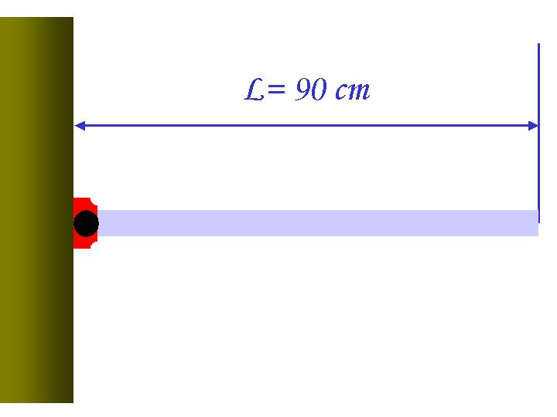

- What is the line density of the rod? ( 4 points)
1. 2.50kg/cm³ 2. 2.00kg/m
3. 2.00kg/cm 4. 2.50kg/m³
Linear density of the rod is defined as mass divided by the length, therefore,
$$λ=\frac{m}{L}=\frac{1\text{.}\text{80}}{0\text{.}\text{90}}=2\text{.}\text{00}{\text{kg}}/m$$
- What is the moment of inertia of the rod in this motion? ( 4 points)
1. $0\text{.}\text{486}\text{kg}⋅m^{2}$ 2. $1\text{.}\text{62}\text{kg}⋅m$
3. $1\text{.}\text{46}\text{kg}⋅m^{2}$ 4. $0\text{.}\text{12}\text{kg}⋅m^{2}$
Using the definition of moment of inertia, one can obtain:
$$I=\int{x^{2}\text{dm}}=\int{x^{2}2\text{.}\text{00}\text{dx}}=\frac{2\text{.}\text{00}}{3}{\left(0\text{.}9\right)}^{3}=0\text{.}\text{486}\text{kg}⋅m^{2}$$
- What is the initial angular acceleration of the rod? ( 4 points)
1. $\text{14}\text{.}6m/{s^{2}}$ 2. $\text{16}\text{.}3m/{s^{2}}$
3. $1\text{.}{\text{62}}/{s^{2}}$ 4. $\text{16}\text{.}3/{s^{2}}$
Since the only force involved in this motion is provided by gravitational acceleration, one can use torque to compute the angular acceleration:
$$\begin{aligned}τ=\text{Fd}=\text{mg}⋅\frac{1}{2}L=1\text{.}8×9\text{.}8×0\text{.}\text{45}=0\text{.}\text{486}α \\ α=\frac{1\text{.}8×9\text{.}8×0\text{.}\text{45}}{0\text{.}\text{486}}=\text{16}\text{.}3/{s^{2}}\end{aligned}$$
- What is the initial linear acceleration in the middle of the rod? ( 4 points)
1. $\text{16}\text{.}3m/{s^{2}}$ 2. $7\text{.}\text{35}m/{s^{2}}$
3. $8\text{.}\text{15}m/{s^{2}}$ 4. $8\text{.}{\text{15}}/{s^{2}}$
Using the relationship between linear and angular acceleration, one can obtain
$$a=rα=\frac{1}{2}Lα=0\text{.}\text{45}×\text{16}\text{.}3=7\text{.}\text{35}m/{s^{2}}$$
- What is the magnitude of torque? ( 4 points)
1. $\text{23}\text{.}6N$ 2. $1\text{.}\text{96}N⋅m$
3. $7\text{.}\text{92}N⋅m$ 4. $\text{17}\text{.}8N$
Since torque is Iα
$$τ=Iα=0\text{.}\text{486}×\text{16}\text{.}3=7\text{.}\text{92}N⋅m$$
Useful Formulae
Velocity: $\vec{v_{f}}=\vec{v_{i}}+\vec{a}t$
Position: $\vec{r_{f}}=\vec{r_{i}}+\vec{v_{i}}t+\frac{1}{2}\vec{a}t^{2}$
Center of Mass: $\vec{r_{\text{CM}}}=\frac{\sum{m_{i}\vec{r_{i}}}}{\sum{m_{i}}}$
Linear Momentum: $\vec{p}=m\vec{v}$
Kinetic Energy: $K=\frac{1}{2}{\text{mv}}^{2}$
Moment of Inertia: $I=\int{r^{2}\text{dm}}$
Torque: $τ=\text{Fd}=Iα$ where d is moment arm and α is the angular acceleration
Rotational Kinetic Energy: $K_{R}=\frac{1}{2}{Iω}^{2}$
The solutions for a 2-dimensional equation:

$${\text{ax}}^{2}+\text{bx}+c=0$$
are:

$x=\frac{−b±\sqrt{b^{2}−4\text{ac}}}{2a}$

