Name:
ID:

[ 1 – 25 points] •A stone of mass 500g was thrown upward from the top of a building at an angle of 60o to horizontal with initial speed of 15.0m/s. The height of the building is 50.0m, and there is no air resistance. The magnitude of the gravitational acceleration is g=9.8m/s². Assume ground is at y=0.

- What are the forces involved in this motion? (2 points)
  - Gravitational, Tangential, and Radial forces
  - Radial, Frictional, and Tangential forces
  - Gravitational force only
  - Gravitational, Frictional, and Radial forces
- What is the magnitude of the gravitational force exerting on this stone? (2 points)
1. 49.0 N 2. 4.90N
3. 9.80N 4. 98.0N
- Which direction is the gravitational acceleration? (2 points)
1. 60o upward to horizontal
2. Horizontal
3. Up when going up and down when coming down
4. Downward
- What is each acceleration component? ( 2 points)
1. $a_{x}=4\text{.}\text{90}m/{s^{2}}$ and $a_{y}=−8\text{.}\text{49}m/{s^{2}}$
2. $a_{x}=4\text{.}\text{90}m/{s^{2}}$ and $a_{y}=8\text{.}\text{49}m/{s^{2}}$
3. $a_{x}=0m/{s^{2}}$ and $a_{y}=−9\text{.}\text{80}m/{s^{2}}$
4. $a_{x}=0m/{s^{2}}$ and $a_{y}=9\text{.}\text{80}m/{s^{2}}$
- What is the potential energy of the stone at the top of the building? ( 3 points)
1. $0J$ 2. $\text{245}J$
3. $\text{212}W$ 4. $\text{212}J$
- How long does it take for the stone to reach its maximum height? ( 3 points)
1. $2\text{.}\text{39}s$ 2. $2\text{.}\text{18}s$
3. $1\text{.}\text{33}s$ 4. $1\text{.}\text{00}s$
- How long would it take for the stone to hit ground? (3 points)
1. $9\text{.}8s$ 2. $4\text{.}\text{79}s$
3. $4\text{.}\text{22}s$ 4. $\text{10}\text{.}0s$
- How far is the stone away from the initial position when it hits ground? ( 2 points)
1. $\text{35}\text{.}9m$ 2. $\text{15}\text{.}0m$
3. $\text{25}\text{.}2m$ 4. $\text{42}\text{.}2m$
- What is the maximum height the stone would reach? ( 3 points)
1. $8\text{.}\text{60}m$ 2. $\text{35}\text{.}7m$
3. $\text{58}\text{.}6m$ 4. $\text{98}\text{.}0m$
- What is the kinetic energy of the stone just before it hits the ground? ( 3 points)
1. $\text{279}J$ 2. $\text{245}J$
3. $\text{301}J$ 4. $\text{287}J$
[ 2 – 15 points] A boat of mass 250kg, heading due south with a speed 20.0km/h is crossing the river whose stream has a uniform speed of 10.0km/h due east.

- Determine the velocity of the boat seen by the observer on the bank. Express the velocity in its magnitude and angle. (5 points)

- What is the kinetic energy of the boat measured by the observer on the river? (5 points)

- The width of the river is 5.0km. How long does it take for the boat to cross the river? (5 points)
[ 3 – 20 points] A car of mass m₁ stopped at a traffic light is rear-ended by a car with mass m₂ (<m₁), and the two become entangled. The lighter car was moving at v_{i} =30.0m/s before the collision.

- What kind of collision is this? (3 points)
1. Elastic Collision 2. Perfectly Inelastic Collision
3. Read-end Collision 4. Perfectly Elastic Collision

- What are the quantities conserved in this collision? (3 points)
  - Mechanical Energy and linear momentum
  - Kinetic energy only
  - Linear momentum only
  - Kinetic energy and linear momentum

- What is the velocity of the entangled cars after the collision in terms of masses m₁ and m₂, and the initial velocity of the lighter car, v_{i}? (4 points)
1.$v_{f}=\frac{m_{2}v_{i}}{m_{1}}$ 2. $v_{f}=\frac{m_{1}v_{i}+m_{2}v_{i}}{m_{1}+m_{2}}$
3. $v_{f}=\frac{m_{2}v_{i}}{m_{1}+m_{2}}$ 4. $v_{f}=\frac{m_{1}v_{i}}{m_{1}+m_{2}}$

- What are the initial kinetic energies of the two cars, if m₁=2500kg and m₂=1000kg? ( 3 points)
1. $\begin{aligned}\left\{K_{1}=\text{11}\text{.}3×{\text{10}}^{5}J | \right.\end{aligned}$ 2. $\begin{aligned}\left\{K_{1}=0J | \right.\end{aligned}$

3. $\begin{aligned}\left\{K_{1}=\text{11}\text{.}3×{\text{10}}^{5}J | \right.\end{aligned}$ 4. $\begin{aligned}\left\{K_{1}=\text{2500}J | \right.\end{aligned}$

- What are the initial linear momenta of the two cars? (3 points)
1. $\begin{aligned}\left\{p_{1}=7\text{.}\text{50}×{\text{10}}^{4}{\text{kg}⋅m}/s | \right.\end{aligned}$ 2. $\begin{aligned}\left\{p_{1}=7\text{.}\text{50}×{\text{10}}^{4}{\text{kg}⋅m}/s | \right.\end{aligned}$

3. $\begin{aligned}\left\{p_{1}=0\text{.}\text{00}{\text{kg}⋅m}/s | \right.\end{aligned}$ 4. $\begin{aligned}\left\{p_{1}=7\text{.}\text{50}×{\text{10}}^{4}J/s | \right.\end{aligned}$

- What is the kinetic of the system after the collision? (4 points)
1. $K_{f}=1\text{.}\text{29}×{\text{10}}^{5}J$ 2. $K_{f}=\text{15}\text{.}3×{\text{10}}^{5}J$
3. $K_{f}=3\text{.}\text{50}×{\text{10}}^{4}J$ 4. $K_{f}=\text{11}\text{.}3×{\text{10}}^{5}J$
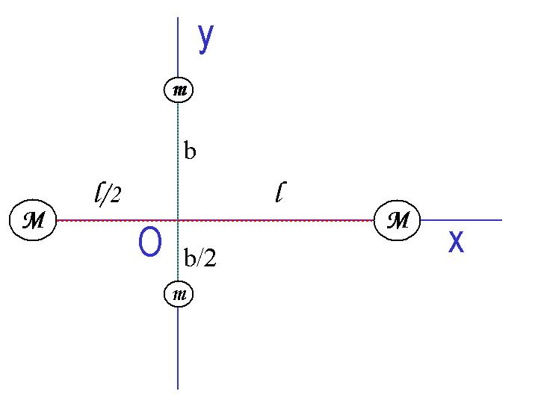
[4 – 20 points]Answer the following questions in a system consists of four small spheres as shown in the figure, assuming the radii are negligible and the rods connecting the spheres are massless.
- Determine the coordinate of the Center of Mass of the system. (5points)

- Compute the moment of inertia and the rotational kinetic energy when the system rotates about the y-axis at ω. (10 points)

- Compute the moment of inertia, using parallel axis theorem and the rotational kinetic energy when the system is rotating about the z axis at ω. (5 points)
[ 5 – 20 points] A uniform rod of length 90.0 cm and mass 1.80kg is attached at one end to a frictionless pivot and is free to rotate about the pivot in the vertical plane, as shown in the figure. Answer the following series of questions, assuming that the rod is released from rest in the horizontal position, and the magnitude of the gravitational acceleration g is $9\text{.}\text{80}m/{s^{2}}$.

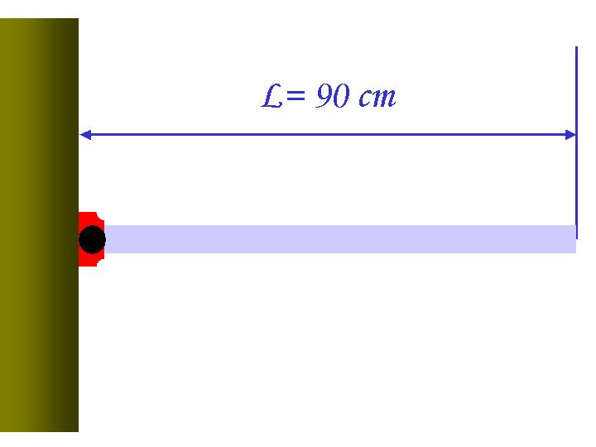

- What is the line density of the rod? ( 4 points)
1. 2.50kg/cm³ 2. 2.00kg/m
3. 2.00kg/cm 4. 2.50kg/m³

- What is the moment of inertia of the rod in this motion? ( 4 points)
1. $0\text{.}\text{486}\text{kg}⋅m^{2}$ 2. $1\text{.}\text{62}\text{kg}⋅m$
3. $1\text{.}\text{46}\text{kg}⋅m^{2}$ 4. $0\text{.}\text{12}\text{kg}⋅m^{2}$

- What is the initial angular acceleration of the rod? ( 4 points)
1. $\text{14}\text{.}6m/{s^{2}}$ 2. $\text{16}\text{.}3m/{s^{2}}$
3. $1\text{.}{\text{62}}/{s^{2}}$ 4. $\text{16}\text{.}3/{s^{2}}$

- What is the initial linear acceleration in the middle of the rod? ( 4 points)
1. $\text{16}\text{.}3m/{s^{2}}$ 2. $7\text{.}\text{35}m/{s^{2}}$
3. $8\text{.}\text{15}m/{s^{2}}$ 4. $8\text{.}{\text{15}}/{s^{2}}$

- What is the magnitude of torque? ( 4 points)
1. $\text{23}\text{.}6N$ 2. $1\text{.}\text{96}N⋅m$
3. $7\text{.}\text{92}N⋅m$ 4. $\text{17}\text{.}8N$
Useful Formulae
Velocity: $\vec{v_{f}}=\vec{v_{i}}+\vec{a}t$
Position: $\vec{r_{f}}=\vec{r_{i}}+\vec{v_{i}}t+\frac{1}{2}\vec{a}t^{2}$
Center of Mass: $\vec{r_{\text{CM}}}=\frac{\sum{m_{i}\vec{r_{i}}}}{\sum{m_{i}}}$
Linear Momentum: $\vec{p}=m\vec{v}$
Kinetic Energy: $K=\frac{1}{2}{\text{mv}}^{2}$
Moment of Inertia: $I=\int{r^{2}\text{dm}}$
Torque: $τ=\text{Fd}=Iα$ where d is moment arm and α is the angular acceleration
Rotational Kinetic Energy: $K_{R}=\frac{1}{2}{Iω}^{2}$
The solutions for a 2-dimensional equation:

$${\text{ax}}^{2}+\text{bx}+c=0$$
are:

$x=\frac{−b±\sqrt{b^{2}−4\text{ac}}}{2a}$

