Be sure to write down answers with units in SI wherever unit is needed.
You must provide answers to all three boldfaced problems and two problems of your choice from the remainder. Extra credit up to 10% of the total will be given to any additional problems answered beyond the required five. There are a total of two pages of problems, front and back. Be sure not to miss them.

- A particle’s motion is described by its position at any given time t.
  - Write down the definition of displacement, average velocity, and acceleration of an object moving in two dimension.
Solution:
Displacement: $Δ\vec{r}=\vec{r_{f}}−\vec{r_{i}}$ or $Δ\vec{r}=\left(x_{f}−x_{i}\right)\vec{i}+\left(y_{f}−y_{i}\right)\vec{j}$
Average Velocity: $\vec{v}=\frac{Δ\vec{r}}{Δt}=\frac{\vec{r_{f}}−\vec{r_{i}}}{Δt}$
Average Acceleration: $\vec{a}=\frac{Δ\vec{v}}{Δt}=\frac{\vec{v_{f}}−\vec{v_{i}}}{Δt}$
  - Derive the instantaneous velocity in terms of time and acceleration.
Solution:
Instantaneous Velocity: $\vec{v}=\underset{Δt→0}{\text{lim}}\frac{Δ\vec{r}}{Δt}=\frac{d\vec{r}}{\text{dt}}=\vec{v_{i}}+\vec{a}t$
  - Derive the position in terms of time, velocity, and acceleration.
Solution:
Average Velocity: $\vec{v}=\frac{Δ\vec{r}}{Δt}=\frac{\vec{r_{f}}−\vec{r_{i}}}{Δt}=\frac{1}{2}\left(\vec{v_{i}}+\vec{v_{f}}\right)$
Position Vector is: $\begin{aligned}\vec{r_{f}}−\vec{r_{i}}=\frac{1}{2}\left(\vec{v_{i}}+\vec{v_{f}}\right)t=\frac{1}{2}\left(\vec{v_{i}}+\vec{v_{i}}+\vec{a}t\right)t=\vec{v_{i}}t+\frac{1}{2}\vec{a}t^{2} \\ ∴\vec{r_{f}}=\vec{r_{i}}+\vec{v_{i}}t+\frac{1}{2}\vec{a}t^{2}\end{aligned}$

- A projectile is fired from the origin at t=0 with a velocity v_{i}, at an angle θ_{i},;
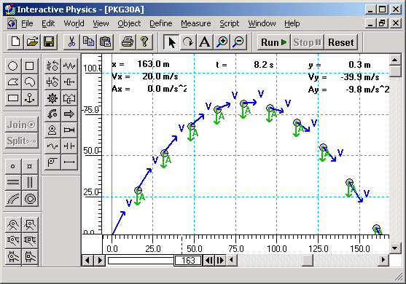
  - Show that the path of projectile motion is a parabola under the influence of earth’s gravitational acceleration, g.
v_{i}
θ
h
Solution:
The total force components:$\sum{F_{x}}={\text{ma}}_{x}=0;\sum{F_{y}}={\text{ma}}_{y}=−\text{mg}$
Therefore, $a_{x}=0;a_{y}=−g$
Using the position vector relationship in the previous problem
$x=v_{\text{xi}}t+\frac{1}{2}a_{x}t^{2}=v_{i}\text{cos}θ_{i}t$ (1)
and
$y=v_{\text{yi}}t+\frac{1}{2}a_{y}t^{2}=v_{i}\text{sin}θ_{i}t−\frac{1}{2}{\text{gt}}^{2}$ (2)
From Eq. (1), one can express time t as
$t=\frac{x}{v_{i}\text{cos}θ_{i}}$ (3)
Replacing t in Eq. (2) with Eq. (3), one gets
$y=x\text{tan}θ_{i}−\frac{{\text{gx}}^{2}}{2v_{i}^{2}{\text{cos}}^{2}θ_{i}}$ (4)
Since y is proportional to x² as shown in Eq. (4), this motion is a parabola.

  - Find the maximum height and the time it takes for the projectile to reach at the maximum height at any initial angle θ_{i},.
Solution:
Since at the maximum height,$v_{y}=0$
Using the velocity to acceleration relationship in problem 1, one can get , $v_{y}=v_{\text{yi}}+a_{y}t=v_{i}\text{sin}θ_{i}−\text{gt}$. Thus the time it takes to be at the maximum height is
$$t=\frac{v_{i}\text{sin}θ_{i}}{g}$$
Then using the position, velocity, and acceleration relations, one gets
$$y=v_{\text{yi}}t+\frac{1}{2}a_{y}t=\frac{v_{i}^{2}{\text{sin}}^{2}θ_{i}}{g}−\frac{1}{2}g\frac{v_{i}^{2}{\text{sin}}^{2}θ_{i}}{g^{2}}=\frac{v_{i}^{2}{\text{sin}}^{2}θ_{i}}{2g}$$
  - Find the maximum range at any initial angle θ_{i}, and the angle that gives maximum range for any projectile
Solution:
Since the projectile reaches at the maximum range in twice the time it needs to reach the maximum height, using the potion to velocity relationship, one can find:
$x=v_{\text{xi}}t=v_{i}^{2}\text{cos}θ_{i}2t=\frac{2v_{i}^{2}\text{sin}θ_{i}\text{cos}θ_{i}}{g}=\frac{v_{i}^{2}\text{sin}2θ_{i}}{g}$. (5)
From Eq. (5) one can tell that the maximum range for any projectile is reached when $\text{sin}2θ_{i}=1$. Therefore, maximum range can be achieved when $2θ_{i}={\text{90}}^{∘}$in other words when the initial firing angle $θ_{i}={\text{45}}^{∘}$.

  - Express this motion vectorially.
Solution:
Using the position vector relationship in the previous problem
$x=v_{\text{xi}}t+\frac{1}{2}a_{x}t^{2}=v_{i}\text{cos}θ_{i}t$ (1)
and
$y=v_{\text{yi}}t+\frac{1}{2}a_{y}t^{2}=v_{i}\text{sin}θ_{i}t−\frac{1}{2}{\text{gt}}^{2}$ (2)
As shown in Eqs. (1) and (2), one can express the motion in vector as
$$\begin{aligned}\vec{r}=x\vec{i}+y\vec{j}=\left(v_{i}\text{cos}θ_{i}t\right)\vec{i}+\left(v_{i}\text{sin}θ_{i}t−\frac{1}{2}{\text{gt}}^{2}\right)\vec{j} \\ \left(v_{i}\text{cos}θ_{i}\vec{i}+v_{i}\text{sin}θ_{i}\vec{j}\right)t−\frac{1}{2}{\text{gt}}^{2}\vec{j}=\vec{v_{i}}t+\frac{1}{2}\vec{g}t^{2}\end{aligned}$$

- A hockey puck on a frozen pond is given an initial speed of 20.0m/s. The puck always remains on the ice and slides 115m before coming to rest.
  - Draw a free-body diagram for this motion and write down the components of all the forces involved in this motion.
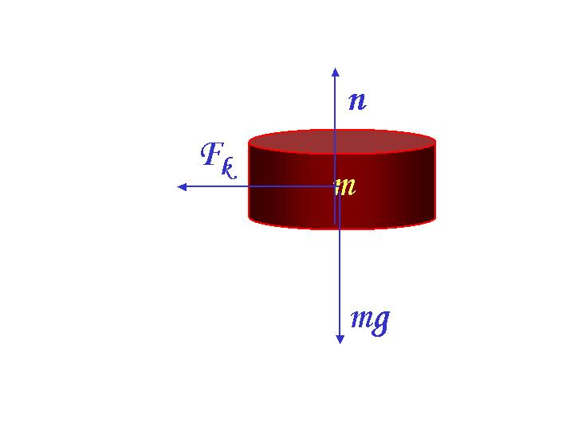
Solution:
The total force exerting on the puck is
$\begin{aligned}\sum{\vec{F}}=\vec{F_{k}}+\vec{n}+m\vec{g} \\ \sum{F_{x}}=F_{k}=−μ_{k}n=−μ_{k}\text{mg} \\ \sum{F_{y}=n−\text{mg}=0}\end{aligned}$ (1)
  - Determine the coefficient of kinetic friction ($μ_{k}$) between the puck and ice. Remember that the force of friction is proportional to normal force.

Solution
From Eq. (1), one can deduce:
$\begin{aligned}\sum{F_{x}}={\text{ma}}_{x}=−μ_{k}\text{mg} \\ ∴a_{x}=−μ_{k}g\end{aligned}$ (2)
Using the position, velocity, and acceleration relationship in problem #1, one can write x coordinate of the puck as:
$x=x_{i}+v_{\text{ix}}t+\frac{1}{2}a_{x}t^{2}$ (3)
By replacing acceleration with Eq. (2), one gets
$Δx=x_{f}−x_{i}=v_{\text{ix}}t−\frac{1}{2}μ_{k}{\text{gt}}^{2}$ (4)
And from velocity to acceleration relationship, one gets time, t, as
$\begin{aligned}v_{f}=0=v_{i}−μ_{k}\text{gt} \\ t=\frac{v_{i}}{μ_{k}g}\end{aligned}$ (5)
Replacing t in Eq. (4) with Eq. (5) and using the total distance the puck traveled before stopping, one gets;
$$\begin{aligned}\frac{v_{i}^{2}}{μ_{k}g}−\frac{v_{i}^{2}}{2μ_{k}g}=\frac{v_{i}^{2}}{2μ_{k}g}=\text{115} \\ μ_{k}=\frac{\text{400}}{\text{230}×9\text{.}\text{80}}=0\text{.}\text{177}\end{aligned}$$

- Show that the acceleration measured in the stationary frame of reference (S) is the same as the one measured in a frame of reference (S’) moving at a constant velocity. Explain what this means.
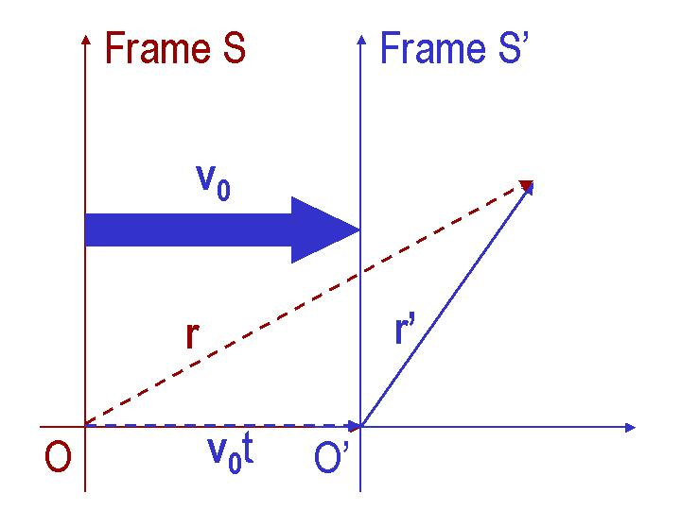
Solution:
The two frames can be drawn as shown above. The position vectors in the two frames are then related as follows:
$\vec{r}=\vec{v_{0}}t+\vec{r'}$ (1)
Therefore, the velocity vectors in the two frames are related
$\vec{v}=\frac{d\vec{r}}{\text{dt}}=\vec{v_{0}}+\frac{d\vec{r'}}{\text{dt}}=\vec{v_{0}}+\vec{v'}$ (2)
This means that the acceleration in these two frames are:
$\vec{a}=\frac{d\vec{v}}{\text{dt}}=\frac{d}{\text{dt}}\left(\vec{v_{0}}+\frac{d\vec{r'}}{\text{dt}}\right)=\frac{d\vec{v'}}{\text{dt}}=\vec{a'}$ (3)
In other words, the acceleration measured in the two frames are identical as long as the two frames move against each other at a constant speed. These two frames are called inertial frames. The physical laws observed in the two inertial frames are identical.

- Drag force of air to an object moving with speed $v$ is expressed as:$R=\frac{1}{2}Dρ{\text{Av}}^{2}$ where D is the drag coefficient, ρ is the density of air, and A is the largest cross section area of the object.
  - Write down the dimension of D, ρ, A, and $v$, then show that R has the dimension of force.
Solution:
[ρ] = [M][L⁻³]
[A] = [L²]
[v] = [L][T⁻¹]
[D] = [1] = Dimensionless
[R] = [M][L⁻³] [L²] [L²][T⁻²]=[M][L][ T⁻²]
Therefore R has the dimension of force.
  - Draw a free-body diagram of a ball of mass m falling in the gravitational field and find the terminal speed of this object.
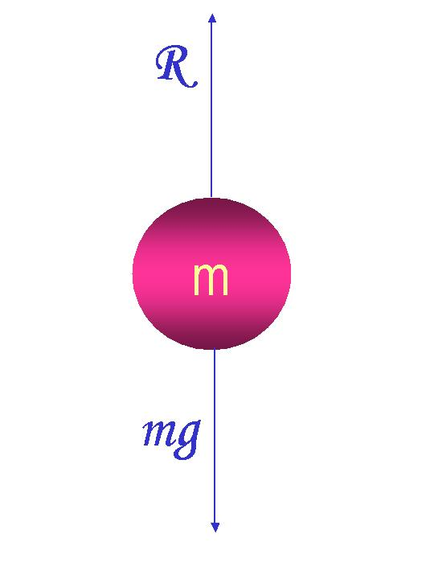
Solution:
One can write all the forces involved in the motion as:
$\begin{aligned}\sum{\vec{F}=\vec{R}+\vec{F_{g}}} \\ F_{x}=0 \\ F_{y}={\text{ma}}_{y}=\frac{1}{2}Dρ{\text{Av}}^{2}−\text{mg}\end{aligned}$ (1)
Since terminal speed occurs when acceleration becomes zero due to balancing of all the forces, using Eq. (1) one can deduce
$\begin{aligned}F_{y}={\text{ma}}_{y}=\frac{1}{2}Dρ{\text{Av}}^{2}−\text{mg}=0 \\ v_{t}=\sqrt{\frac{2\text{mg}}{DρA}}\end{aligned}$ (2)
  - Explain how the terminal speed depends on the size of the ball.

Solution
From Eq. (2), one can replace the largest cross section area of the ball with its radius. Since the area of a circle is πr², one gets
$v_{t}=\sqrt{\frac{2g}{D\text{ρπ}r^{2}}}=\sqrt{\frac{2g}{D\text{ρπ}}}\frac{1}{r}$ (3)
So the terminal speed is inversely proportional to the radius of the ball.
  - Consider a pitcher throwing a ball of mass 200g at a speed 160km/sec. Find the resistive force on the ball. The mass of the air is 2.0mg in 1 cm³. The diameter of the ball is 7.4 cm. The gravitational acceleration is 9.80m/s².
Solution
First one needs to compute the air density from the given information:
$ρ=\frac{m}{V}=\frac{2\text{.}0×{\text{10}}^{−6}\text{kg}}{1×{\text{10}}^{−6}m^{3}}=2{\text{kg}}/{m^{3}}$ (4)
One then needs to compute the area of the ball using the radius
$A={πr}^{2}=\frac{1}{4}π{\left(3\text{.}7×{\text{10}}^{−2}m\right)}^{2}=1\text{.}1×{\text{10}}^{−3}m^{2}$ (5)
Now, using the formula given in problem 5-a, one can get
$R=\frac{1}{2}Dρ{\text{Av}}^{2}=\frac{1}{2}D×2×1\text{.}1×{\text{10}}^{−3}×{\left(\text{160}×{\text{10}}^{3}\right)}^{2}=\text{30}D×{\text{10}}^{6}N$ (6)
Now physically this does not make sense, because no pitcher can throw a ball as 160km/s. This must have been a typo. The reasonable speed would be 160km/h. The final result cannot be expressed in a number because the value of D is not given.

- A hailstone of mass 0.480 g falls through the air and experiences a net force given by $F=−\text{mg}+{\text{Cv}}^{2}$ where $C=2\text{.}\text{50}×{\text{10}}^{−5}{\text{kg}}/m$.
  - Compute the terminal speed of the hailstone.
Solution
From the expression of the force one can obtain terminal speed by setting acceleration 0:
$\begin{aligned}F=\text{ma}=−\text{mg}+{\text{Cv}}^{2}=0 \\ v_{t}=\sqrt{\frac{\text{mg}}{C}}=\sqrt{\frac{4\text{.}\text{80}×{\text{10}}^{−4}×9\text{.}\text{80}}{2\text{.}\text{50}×{\text{10}}^{−5}}}=\text{13}\text{.}7m/s\end{aligned}$ (1)
  - Use Euler’s method of numerical analysis to find the speed and position of the hailstone at 0.2 s intervals for a total of 1 second, taking the initial speed to be 0.
Solution
In order to use Euler’s method of numerical analysis, one must first express speed and position of the hailstone in terms of time. Using the expression of force one can obtain
$\begin{aligned}F=\text{ma}=−\text{mg}+{\text{Cv}}^{2}=0;a=−g+\frac{C}{m}v^{2} \\ v=v_{i}+\text{at}=\text{at}=\left(−g+\frac{C}{m}v^{2}\right)t \\ \frac{C}{m}{\text{tv}}^{2}+v+\text{gt}=0 \\ v=\frac{−1±\sqrt{1+4×\frac{\text{gCt}}{m}}}{\frac{2\text{Ct}}{m}}\end{aligned}$ (2)
Since speed must be positive (because it is the magnitude of velocity vector) the only physical solution for speed is
$v=\frac{−1+\sqrt{1+4×\frac{\text{gCt}}{m}}}{\frac{2\text{Ct}}{m}}$ (3)
One can also obtain x as a function of all known quantities as
$x=\text{vt}+\frac{1}{2}\left(−g+\frac{{\text{Cv}}^{2}}{m}\right)t^{2}$ (4)
One can then compute speed and position at any time interval.
Time T+0.2 | Speed | Position
0.2
0.4
0.6
0.8
1.0

- Gravitational force between two objects with mass m₁ and m₂ is given by Newton’s law of gravitation; $F=G\frac{m_{1}m_{2}}{r^{2}}$ where $G=6\text{.}\text{673}×{\text{10}}^{−\text{11}}{N⋅m^{2}}/{\text{kg}}$ is the gravitational constant, and r is the distance between the two objects.
  - Consider a satellite of mass m moving in a circular orbit around the earth at a constant speed v and at an altitude h. above the Earth’s surface. Determine the speed of the satellite in terms of G, h, and Earth’s radius R_{E}. The radial acceleration is given as $a_{r}=\frac{v^{2}}{r}$
Solution
Since the total distance between the satellite at height h above the Earth’s surface and the center of the Earth is h+R_{E}, using the radial acceleration, one can obtain
$\begin{aligned}F={\text{ma}}_{r}=m\frac{v^{2}}{r}=\frac{{\text{GmM}}_{E}}{r^{2}} \\ v=\sqrt{\frac{{\text{GM}}_{E}}{r}}=\sqrt{\frac{{\text{GM}}_{E}}{h+R_{E}}}\end{aligned}$ (1)
  - Compute the speed and the time for a complete circular motion around the Earth for a satellite at an altitude of 1000 km, circling the Earth. The radius of the Earth is $R_{E}=6\text{.}\text{37}×{\text{10}}^{3}\text{km}$ and its mass is $M_{E}=5\text{.}\text{98}×{\text{10}}^{\text{24}}\text{kg}$.
Solution
Sine we know the formula for speed in terms of all known quantities, we can compute the speed and time for a complete circulation by putting the actual numbers into the formula.
$$\begin{aligned}v=\sqrt{\frac{{\text{GM}}_{E}}{h+R_{E}}}=\sqrt{\frac{6\text{.}\text{673}×{\text{10}}^{−\text{11}}×5\text{.}\text{98}×{\text{10}}^{\text{24}}}{\text{10}×6+6\text{.}\text{37}×{\text{10}}^{6}}}=7\text{.}\text{36}×{\text{10}}^{3}m/s \\ t=\frac{2πr}{v}=\frac{2π\left(\text{10}×6+6\text{.}\text{37}×{\text{10}}^{6}\right)}{7\text{.}\text{36}×{\text{10}}^{3}}=6\text{.}\text{29}×{\text{10}}^{3}s\end{aligned}$$

